PLANNING AND PROGRAMME DEVELOPMENT IN EARLY CHILDHOOD SETTINGS

LEARNER GUIDE

Module # | 234201000-KM-03
NQF Level | level 4
Notional hours | 80
Credit(s) | Cr 8
Curriculum Code | 234201000
SAQA QUAL ID | 97542
Qualification Title | Occupational Certificate: Early Childhood Development Practitioner: L4-131 credits

CONTACT INFORMATION:

Name
Contact Address
Telephone (H)
Telephone (W)
Cellular

TABLE OF CONTENTS

PURPOSE OF THE QUALIFICATION 4
QUALIFICATION RULES 6
EXIT LEVEL OUTCOMES 8
ENTRY REQUIREMENTS: 9
ARTICULATION OPTIONS 10
ASSESSMENT REQUIREMENTS 11
PROVIDER ACCREDITATION REQUIREMENTS FOR THE MODULE: 12
SECTION 1: KM-03-KT01: Early childhood learning environments (35%) 14
1.1 National Curriculum Framework, guidelines and documents for early childhood development 14
1.2 Play in early education and childcare 19
SECTION 2: KM-03-KT02: Equality, diversity and inclusion in childhood development (30%) 43
2.1 Promotion of anti-bias practices and ensuring equality of opportunities 43
2.2. Importance of the child's first language 62
2.3 Promoting self-regulation 63
SECTION 3: KM-03-KT03: Early Childhood Development Programmes (35%) 69
3.1 Early Childhood Development-related programmes 69
3.3 Programme planning and evaluation 116

PURPOSE OF THE QUALIFICATION
Purpose:
The purpose of this qualification is to prepare a learner to operate as an Early Childhood Development Practitioner.
An Early Childhood Development Practitioner plans and prepares early childhood activities, facilitates and mediates learning, observes and assesses the progress of children, and reflects on learning in an inclusive, play-based environment to support holistic development of children (from conception - school going) in different centre-based or non-centre based settings.

A qualified learner will be able to:
• Plan and prepare broad-phase learning environment and stimulating activities that meet the holistic needs of all children in centre-based or non-centre-based settings.
• Facilitate and mediate all aspects of the daily programme in a centre-based or non-centre based setting.
• Observe, assess and record each child's progress according to the age and stage.
• Compile a report of each child's progress.
• Maintain and promote the well-being, health, nutrition, safety and protection of children.

Rationale:
The Occupational Certificate: Early Childhood Development has been designed to meet the needs and interests of the early childhood development sector in a variety of settings and contexts with an inclusive focus on education, health and safety issues, amongst others. There is a vast need for early childhood development services and it is critical that the field must be served by competent practitioners. In order to meet the needs at early childhood development level, it is important to be able to identify and recognise competent early childhood development practitioners who are able to work in centre-based and non-centre-based early childhood development settings.

This qualification will provide a means to give recognition to practitioners at an entry level, thus making it possible for practitioners to increase their employment prospects within the Department of Basic Education. The Department of Social Development, through the registration of early childhood development centres and/or sites, may also provide business opportunities to successful practitioners who may wish to establish early childhood centres and/or sites. It will also provide access to a recognised career path and at the same time provide the field with suitably qualified professional practitioners.

The qualification will provide opportunities to people who wish to enter and/or continue learning in the early childhood development field, which include the employed, under-employed but not qualified, and school leavers. Every child has the right to high-quality, holistic education and care which forms the critical foundation for further development and learning from childhood into adulthood.

This necessitates the universal availability of high-quality early childhood development and education as a vital strategy to yield personal and long-term benefits to individual children, their families and the society at large.

Early childhood development is an essential component of economic development within the framework of child care services. Changing social and economic needs require parents to enter the labour market. Therefore quality early childhood development service provision is required to meet growing demands in the country, both in urban and rural settings.
.

QUALIFICATION RULES
This qualification is made up of the following compulsory Knowledge Modules, Practical Skill Modules and Work Experience Modules totalling 131 Credits:

Knowledge Modules: 43 Credits:
• 234201000-KM-01, Introduction to the early childhood development sector, at NQF Level 4, 4 Credits.
• 234201000-KM-02, Theories and Perspectives of Child Development, at NQF Level 5, 6 Credits.
• 234201000-KM-03, Planning and Programme Development in early childhood settings, at NQF Level 4, 8 Credits.
• 234201000-KM-04, Facilitation and mediation of active learning, at NQF Level 5, 12 Credits.
• 234201000-KM-05, Observation and assessment in early childhood development, at NQF Level 4, 4 Credits.
• 234201000-KM-06, Promotion of health, safety and well-being of children, at NQF Level 4, 6 Credits.
• 234201000-KM-07, Administration for early childhood development services and programmes, at NQF Level 3, 3 Credits.

Practical Skill Modules; 43 Credits:
• 234201000-PM-01, Plan and prepare inclusive educational activities and routines using an approved programme based on the curriculum framework, at NQF Level 4, 12 Credits.
• 234201000-PM-02, Facilitate and mediate active learning in an integrated and holistic learning programme, at NQF Level 5, 9 Credits.
• 234201000-PM-03, Observe, assess, record and report each child's progress according to the age and stage, at NQF Level 4, 4 Credits.
• 234201000-PM-04, Support and promote the health, nutrition, safety, protection and well-being of children, at NQF Level 4, 12 Credits.
• 234201000-PM-05, Build and maintain collaborative relationships with parents and other service providers, at NQF Level 4, 3 Credits.
• 234201000-PM-06, Prepare and maintain administrative systems, at NQF Level 3, 3 Credits.

Work Experience Modules; 45 Credits:
• 234201000-WM-01, Learning programme and routines planning and preparation process, at NQF Level 4, 13 Credits.
• 234201000-WM-02, Processes of facilitating and mediating the learning programme in a variety of contexts, at NQF Level 4, 15 Credits.
• 234201000-WM-03, Processes of observation, assessment, recording and reporting on children's learning and development, at NQF Level 4, 7 Credits.
• 234201000-WM-04, Processes and procedures of promoting the health, nutrition, safety, protection and well-being of children in an early childhood development setting, at NQF Level 4, 10 Credits.

EXIT LEVEL OUTCOMES
1. Plan and prepare broad-phase learning environment and stimulating activities that meet the holistic needs of all children in centre-based or non-centre-based settings.
2. Facilitate and mediate all aspects of the daily programme in a centre-based or non-centre based setting.
3. Observe, assess and record each child's progress.
4. Compile a report of each child's progress.
5. Maintain and promote the well-being, health, nutrition, safety and protection of children.

Occupation Regulation
All trades are regulated by the Department of Higher Education and Training (DHET) through the National Artisan Moderation Body (NAMB). To become a qualified artisan you have to pass a trade test at a national trade test centre that is accredited by the Quality Council for Trades and Occupations (QCTO). All national trade test centres are quality assured and recommended for accreditation by the NAMB.

ENTRY REQUIREMENTS:

LEARNING ASSUMED TO BE IN PLACE AND RECOGNITION OF PRIOR LEARNING
Recognition of Prior Learning (RPL):
RPL for access to the external integrated summative assessment: Accredited providers and approved workplaces must apply the internal assessment criteria specified in the related curriculum document to establish and confirm prior learning. Accredited providers and workplaces must confirm prior learning by issuing a Statement of Results or certifying a Work Experience Record.

RPL for access to the Qualification: Accredited providers and approved workplaces may recognise prior learning against the relevant access requirements.

Entry Requirements: • National Certificate Vocational (NCV) at NQF Level 3.
Or
• Any other NQF Level 3 qualification.

ARTICULATION OPTIONS

Horizontal Articulation:
• Further Education and Training Certificate in Early Childhood Development, NQF Level 4, SAQA ID: 58761.

Vertical Articulation:
• National Certificate in Early Childhood Development, NQF Level 5, SAQA ID: 58761.
• National Diploma in Early Childhood Development, NQF Level 5, SAQA ID: 64650.

ASSESSMENT REQUIREMENTS
Integrated Formative Assessment: The skills development provider will use the curriculum to guide them on the stipulated internal assessment criteria and weighting. They will also apply the scope of practical skills and applied knowledge as stipulated by the internal assessment criteria. This formative assessment leads to entrance into the integrated external summative assessment.

Integrated Summative Assessment:
The external summative assessment will be a trade test conducted in terms of Section 26 D of the Skills Development Act through an evaluation of written and practical tasks covering critical aspects of the trade and conducted in a simulated environment at an assessment centre accredited by QCTO by an assessor registered by National Artisan Moderation Body. The assessment will take place over a minimum of 2 days.

PROVIDER ACCREDITATION REQUIREMENTS FOR THE MODULE:

Physical Requirements:
• Training venue/classroom, chairs, desks and tables
• Training material and resources

Human Resource Requirements:
• The trainer must have an NQF Level 5 or higher Early Childhood Development Qualification or equivalent
• Registered Assessor with ETDP SETA is a recommendation
• The trainer with facilitation skills is a recommendation
• Trainer to learner ratio: 1:30 (Maximum)

Legal Requirements:
• Legal Entity
• Accredited skills development provider with ETDP SETA
• Compliant with Occupational Health and Safety legislation and requirements

Exemptions
None

TOPIC ELEMENTS TO BE COVERED INCLUDE:
- The main focus of the learning in this Knowledge Module is to build an understanding of inclusive early childhood learning environments, including equality, diversity and early childhood programmes.

- The learning will enable learners to demonstrate an understanding of:
- KM-03-KT01: Early childhood learning environments (35%)
- KM-03-KT02: Equality, diversity and inclusion in childhood development (30%)
- KM-03-KT03: Early Childhood Development Programmes (35%))

SECTION 1: KM-03-KT01: Early childhood learning environments (35%)

Learning Outcome

At the end of this section, learners should cover:

- KT0101 National Curriculum Framework, guidelines and documents for early childhood development
- KT0102 Play in early education and childcare
- KT0103 Stimulating and supporting early learning in a home environment

National Curriculum Framework, guidelines and documents for early childhood development

The National Curriculum Framework (NCF) provides guidance for those developing programmes and working with babies, toddlers and young children from birth to age four. The document is aimed at adults working with children from birth to four and includes:
• Parents and caregivers
• Early childhood practitioners (in centres, family and community support services, child minders)
• Practitioner/educator and support staff
• Monitoring personnel (government and civil society) who visit the ECD programmes. It can also assist in supporting older children (buddies) who offer child–to child ECD interventions in South Africa. Adults need to work together to make meaning of and to apply the NCF through paying attention to high quality experiences for babies, toddlers and young children in a variety of programmes and settings such as ECD centres, homes, neighbourhoods and institutions where children in the early years are cared for. In South Africa, as elsewhere in the world, there is an increasing drive to value and support the development and learning of children in the early years. Research shows that the first 1000 days (pre-birth, early and late infancy) of life are highly sensitive to environmental effects. Evidence from research in South Africa shows that the early years are building blocks for health, human capacity, personal and social well-being. A key feature that makes ECD programmes in South Africa different from other countries is the urgent need to effect social transformation through integrated care and education for our youngest children. This needs to happen because of:
• the history of apartheid;
• inequalities and conditions that place young children at risk;
• improve quality provisioning for children birth to four;
• the need to professionalise the workforce; and
• the need to promote a new vision for citizens in democratic South Africa. The NCF promotes a holistic vision of ECD which pays attention to:
• The first 1000 days which are the windows of opportunities for interventions before birth and the first two years of life after birth; and
• The third and fourth years of life and the time before the child enters primary school The NCF therefore focuses upon the child from before birth through to the time that she enters Grade R. The NCF draws on the values in our constitution, the principles set out in existing legislation, policies and plans, review of South African curricula for birth to four (Free State, Gauteng, Limpopo), the findings from the international literature on ECD, global imperatives for ECD and voices from the ECD field (through the stakeholder consultations carried out in South Africa). The National Early Learning Standards (NELDS) form the foundation for the NCF. 2 Comprehensive version The vision

The NCF is driven by the following vision: Working with and for all children in the early years in a respectful way to provide them with quality experiences and equality of opportunities to achieve their full potential.

A curriculum framework
A curriculum framework is an organising tool which includes
• the knowledge and understanding of the world
• the practical skills required and
• the attitudes and behaviours needed to develop citizens All of the knowledge, skills and behaviours which we need as human beings and citizens are described as ‘competence’. Competent human beings and citizens have enough useful knowledge, useful skills and positive attitudes for living healthy, productive and happy lives. This NCF describes the competence that babies, toddlers and young children hope to and need to develop. The NCF describes the aims
• for children’s development and learning which need to be used as guidelines for supporting children’s holistic development and assessment of children’s progress and potential.
• for adults who are facilitating children learning by planning high quality experience and by reflecting on and evaluating their performance. The content of NCF relating to children’s development and learning is NOT TO BE USED IN A PRESCRIPTIVE WAY. It is a flexible tool to create opportunities for quality experiences for babies, toddlers and young children. The NCF provides guidance on how to develop a curriculum appropriate for babies and young children. A curriculum for early childhood is about all the experiences that children from birth to four will have in different settings. What children feel, do, hear and see in their early childhood setting is an important part of curriculum. Curriculum includes experiences
• that are planned for young children wherever they are being cared for and educated (adult- initiated)
• which are not consciously planned by adults (incidental learning/ teachable moments)
• created by the children themselves in order to make sense of their world (child- initiated).

The aim of the curriculum is to help every child to develop knowledge, skills, attitudes and behaviours for life, learning, schooling and work. The definition ensures that ECD programmes in South Africa are based on a holistic approach to children’s development and learning. This approach helps adults to develop effective practice through
• planning and offering activities to meet the needs and interests of each child in different settings and
• integrating what works best for babies, toddlers, and young children at family, local, national and international contexts The links between the NCF with other curriculum initiatives/frameworks The NCF is one of a number of curriculum initiatives. All curriculum frameworks in all sectors of education are based on the South African Constitution. The ECD sector includes children from birth to nine: prior schooling (birth to 4) and the schooling phase (5 to 9 years). The NELDS, the NCF, the GPD and the CAPS document are interrelated as follows:

The Purpose of the NCF
The NCF seeks to:
• affirm young children as competent people who are actively involved in their learning
• actively honour the diversity of our young children, their capabilities, their languages and their heritage
• promote young children’s experiences of socially and culturally sensitive environments where attention is paid to inclusive, equitable and democratic practices
• recognise the importance of the local context and indigenous resources for early learning and therefore provide a supportive structure for adults which would encourage and enable them to create, build and to develop curriculum to suit the needs and interests of children, families, neighbourhoods and communities
• deepen the understanding of the essential learning areas and relate it to building a programme relevant to ways in which young children develop and learn
• value curriculum as a process where critical reflection informs teaching, learning and the creation of effective practice for diverse contexts
• develop an asset-based approach when supporting adults who care for and educate young children.
• help with reflection on the relevance and effectiveness of the ECD programme
• bring together the division of care and education by taking into account the learning and development requirements in the - the NELDS (education focus) - the Children’s Act and the Early Childhood Service Standards (care and social development focus)
• develop a shared vision and professional language for the ECD field through common values, principles and aims to guide integrated care and education in varied settings

The NCF and the National Qualifications Framework
The National Qualifications Framework (NQF) is a Framework on which standards and qualifications, agreed to by education and training stakeholders are registered. The NQF is a means for transforming education and training in South Africa. It has been designed to
• make it easier for people to enter the education and training system and to move and progress within it
• open learning and work opportunities for those who were treated unfairly in the past because of their race or gender
• enable people to develop to their full potential and thereby support the social and economic development of the country. The NCF forms the beginning of this process of lifelong learning within the principles and values of the National Qualifications Framework. The National Qualifications Framework sets out the Critical Outcomes which are designed for all educational programmes in South Africa. The NCF reflects these. They are that young children should learn to
• identify and solve problems and make decisions using critical and creative thinking; • work effectively as individuals and with others as members of a team;
• organise and manage themselves and their activities responsibly and effectively;
• collect, analyse, organise and critically evaluate information;
• communicate effectively using visual, symbolic and/or language skills in various modes;
• use science and technology effectively and critically showing responsibility towards the environment and the health of others; and
• demonstrate an understanding of the world as a set of related systems by recognising that problem-solving contexts do not exist in isolation Each of these Critical Outcomes is integrated into each of the six Early Learning and Development Areas.

The NCF must be appropriate in a contextual, developmental and educationally appropriate way. There are therefore three themes which emerge from the attention to appropriateness. They are 1. Young children as people 2. Young children’s learning and development 3. Young children’s connections with adults

Play in early education and childcare

Learning environment
The learning environment is the physical space provided both indoors and outdoors for babies, toddlers and children to play.

Remember that play = learning

It is no coincidence that we refer to these areas as the playroom and playground because the way that you set up these areas will encourage children to play and thus to learn.

Use of space
You need to plan your activities bearing in mind the space available to you as well as the needs of each particular activity. You will need to consider the following:

- Is it a group or individual activity? Group activities obviously require more space but it depends on the group size. Large group activities such as music or morning ring will need more space that smaller groups and you may have to move furniture to accommodate all the children.
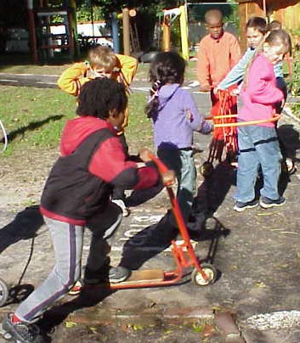
- Is it indoors or outdoors? The garden needs to have a variety of trees, flowers, and shrubs with space for the children to grow seeds, flowers and vegetables, investigate bugs and collect rocks, leaves or other natural objects. It also needs space for climbing equipment, open areas to run and space for wheel toys. Remember that the outdoor area can also be used to set up art activities – particularly those that are very messy or need more space. You can also read a story in the shade of a tree on a hot day.
- Wheel toys such as tricycles, karts etc need a paved or hard surface to be used effectively.
- It is vital that items are stored as close as possible to where they will be used.

Types of learning activities

- Book areas need to be in a quieter area of the class and not right next to noisy play.
- Block areas require lots of space for children to build imaginative structures.
- Levels available – sitting on the floor, kneeling at a box or sitting at table and chairs. Some activities like emergent literacy and numeracy naturally need tables to work at while blocks rely on a flat surface such as the floor or carpet. Some art activities like box construction can be done on a plastic mat, which can be packed away when not in use.

Creative activities are often messy and thus they should be planned for areas that are tiled and easy to clean. They should be close to a source of water to facilitate preparation of paints etc, and for cleaning up.
- Free play activities allow children to choose an area to play in. Areas such as book, block etc should cater for about four children at a time.
- Traffic patterns in the classroom need to be planned for as well. Children and adults should be able to move freely from one area to another. There should no furniture blocking doorways. Children should not be bumping into each other or equipment when they are moving around.
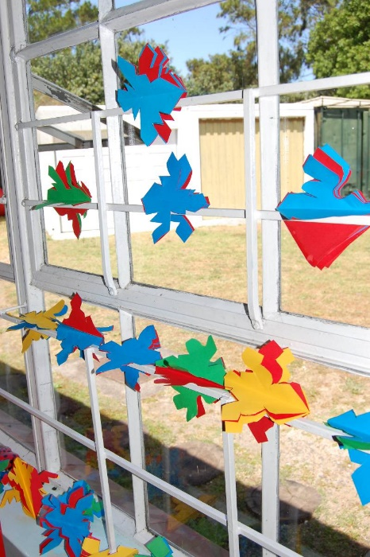
Toilets should be easily accessible from both indoor and outdoor areas. Children often need to get to the toilet in a hurry and should not have to dodge around structures.
Display space is needed on the walls for artwork and things relevant to the weekly theme. These must all be at the children's eye-level.
Storage space is needed so that all the resources and equipment is well organised (have its place) and easily accessible for both the ECD practitioner and the children.
The indoor area needs to be well lit and airy. Windows need to let in enough light, be low enough for the children to see out and have curtains or blinds that close tightly for sleep time.
Figure 4.2 Indoor areas need to be well lit
Each child needs a storage area for his/her personal items.
Furniture that is stackable and moveable is ideal as it allows for flexible use of space. Chairs and tables can be stored out of the way when an area is needed for music, movement or other large group activities.

Health and safety issues
- The ECD practitioner in a class should be able to see into all the play areas so that she can supervise the children effectively. Cupboards and shelves should be low so that an adult can see over them.
- Carpets and mats should not be loose to prevent people from slipping. They should also not have corners that are sticking up that could result in someone tripping.
- Plugs should be covered or blocked by heavy furniture so that children cannot easily access them and shock themselves. Do not overload plugs or use electrical equipment with frayed cords. Children should not be able to pull on electrical cords either. Wall mounted heaters that are above the reach of the children are preferable for winter.
- The younger the child, the more supervision they need.
  - Babies should never be left alone. Everything goes into their mouths so avoid resources that can be choking hazards or toxic. Also ensure that each baby's bottles, dummies and personal toys are clearly marked to avoid spreading infections. For babies who are learning to crawl there must be no sharp edges on furniture.
  - Toddlers like climbing and get into dangerous situations if they are also not constantly supervised. Once they are mobile, gates are needed at the top and bottom of stairs. Storage boxes must either have lightweight lids, no lids or safe-closing hinges. Cupboards containing potentially hazardous items such as the first-aid kit or cleaning products must have safety latches or locks.
  - Young children can manage certain activities on their own but you still need to be vigilant and keep an eye on them. Teach young children to put the resources away after an activity so that the resources do not get broken and so that no one trips over them and falls.
- Clean up liquid spillages on tiled floors immediately as children and adults could slip in them.
- Enough space must be provided for activities so that children can move without bumping into equipment. When children feel overcrowded they begin to argue and fight with their peers.
- Provide enough resources so that children are stimulated and do not have to fight over equipment or wait too long for a turn.
- Scissors and other potentially dangerous items need to be stored properly so that they are only used under supervision.
- Equipment needs to be secure and well balanced so that it does not fall onto a child if pulled on – particularly with toddlers and babies.
- Children must be supervised when using water and any basins, troughs etc should be emptied immediately after use.
- Make sure that equipment is used for the intended purpose as misuse might be a potential hazard.

Storage
You will need both indoor and outdoor storage areas as resources need to be close to where they will be used. If there is space, it is ideal to have shared storeroom indoors for all ECD facilitators where the following can be stored:

- ‘Junk” that is collected for art like boxes, polystyrene chips etc.
- Paint, glue etc.
- Paintbrushes, rollers etc.
- Theme boxes: Photostat lids or boxes are ideal for storing items that belong to a particular theme. They can be labelled and thus become easily accessible when needed.
- Extra puzzles, games, toys that are not being used.

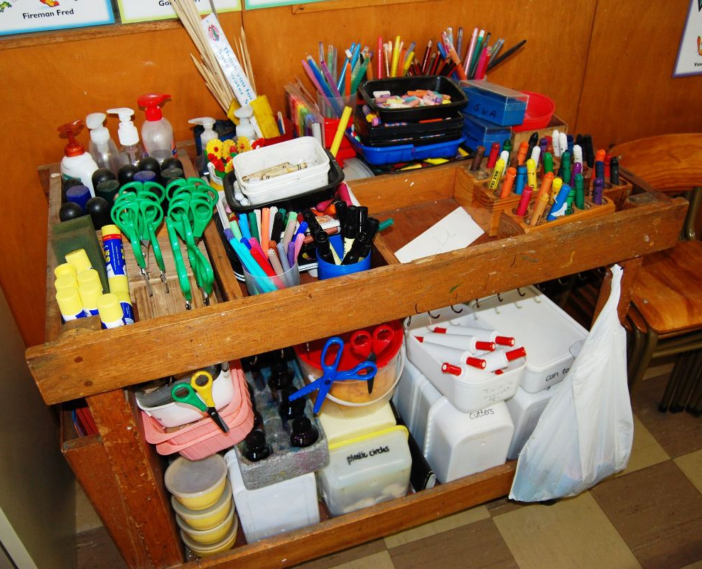

Storage can be maximised in the classroom in many ways.
- Babies’ cots may have drawers underneath where toys or personal items can be stored.
- You can install high shelves within your reach but out of the children’s reach. This is ideal for items that are not needed on a daily basis.
- Drag boxes, boxes or crates used for children to kneel at can have lids fitted so that items can be stored inside.
- Art trolleys are available on castors where day-to-day items can be neatly packed and wheeled out of the way when needed.

It is very important for children’s sense of security that they know where things are and that the environment is well ordered. Teaching them to sort and store items neatly and logically is an important life skill.

Boxes, tins and other items can be recycled and used to store items in the class. Here are some very basic ideas:

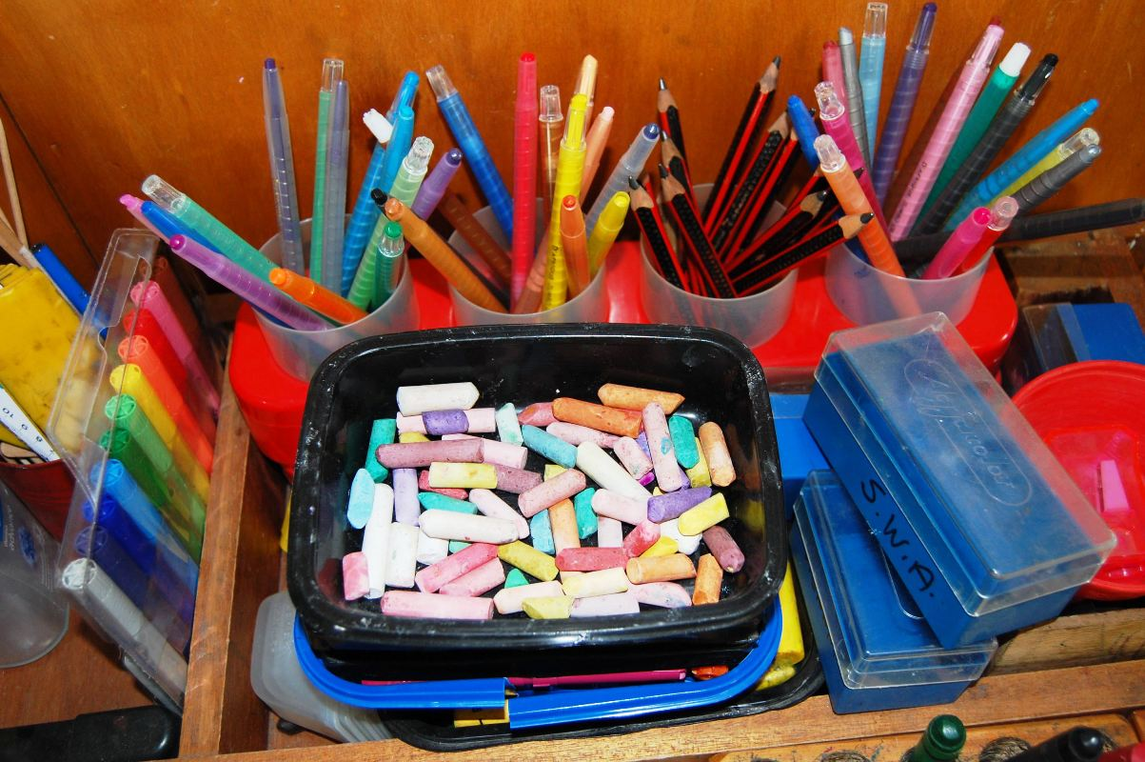
- Ice-cream tubs with lids can be stacked with items like crayons or kokis in them.
- Larger tins can be used for storing paintbrushes so that they can dry. Make sure that the bristles are stored upwards. A4 paper can also be rolled up and stand on the literacy table in a tin. The tins can be painted or covered with coloured paper to make them more attractive. Keep the plastic lid and put it on the bottom of the tin to prevent it from slipping or marking surfaces.
- A magazine or paper storage box can be created by cutting off the top of a large cereal box. Then drawing a line from the top left-hand corner of the box to the middle of the right-hand side of the box. Making an identical line on the opposite side of the box. Once you have cut alone these lines, you will have an upright storage box.
- Stacking paper trays can also be made easily. Take three or four cereal boxes and cut the top flaps off each of the cereal boxes. Stack the boxes on top of each other and stick them together with tape. Then cover the outside of the stack neatly with a large sheet of wrapping paper, brown paper, newsprint or newspaper. You can store your paper in this paper filing system. If your boxes start to bend, you can stick a piece of thin wood (for example, an ice cream stick) on each side to add extra support.
- A multi-sized storage unit or giant sorting tray can also be made to store a variety of things like wool, tinfoil or shiny paper, shells, fabric scraps, buttons, small machine parts and seedpods. Take a large cardboard box and cut off the top flaps. Turn the box on its side. Find smaller boxes that can fit neatly inside the bigger box like shoe boxes, porridge boxes or tea boxes. Arrange these small boxes inside the big box.
Children need personal storage space for their bags, snacks if they bring them to school, art aprons, message books, change of clothes, sun screen etc. It is ideal if this is in a passage just outside the class so that the items can be accessed quickly in order to promote independence. They will also need hooks in the toilet area for their personal cloths.

The outdoor storeroom would be used for items such as the wheel toys, balls, sand and water play that cannot be left outside overnight. It should also be neat and cleaned out regularly as it can be the ideal nesting place for rats, spiders and other creatures. It is a good idea to use plastic crates as cardboard boxes rot easily – especially if it is damp.

Always remember that safety is imperative and that any poisonous or cleaning substances and medicines should be securely locked away out of the reach of curious young children.
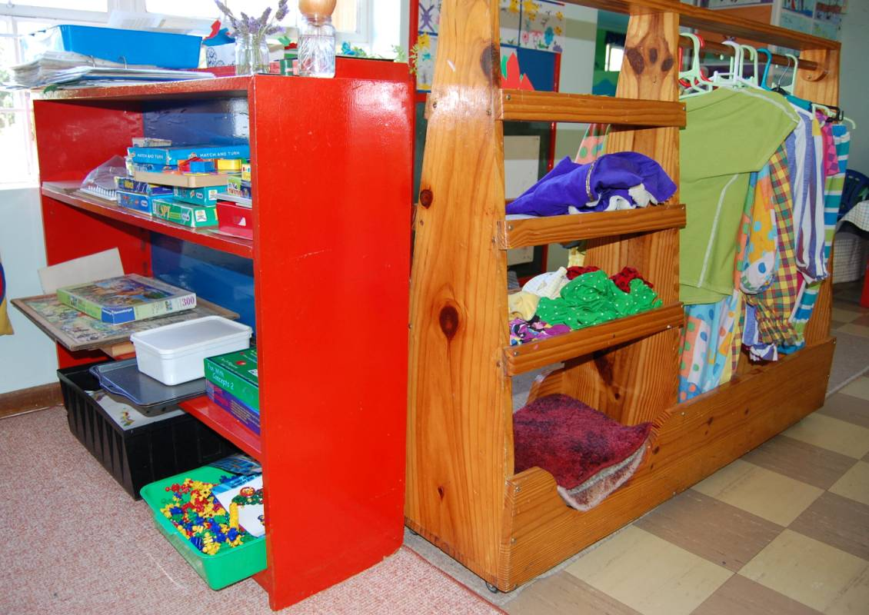
Accommodating special needs
If you have children with special needs in your class, they will also need to be comfortable and to move around freely. This is particularly relevant to children with physical disabilities who rely on crutches or wheelchairs for mobility.

You can assist the children by making sure that:

- Ramps are available to enter the indoor area and so that the child has access to the outdoor area
- Pathways are wide enough outdoors for a wheelchair to be pushed on them
- Toilet doors are wide enough to allow wheelchair access and that there are bars on the walls of the toilet for them to hold onto.
- There are ‘pathways’ in the class for the children to move without bumping into furniture
- Resources and equipment are stored at a height that that they can access so they are not dependent in all situations
- Resources are adapted where need be to accommodate their needs

You will need to be very sensitive to the physical needs of all children with special needs so that the environment does not further compromise their learning opportunities.

Many ECD practitioners focus on planning the activities such as morning ring, art, movement, music and story and forget that children learn incidentally too. A well set out and resourced indoor area can stimulate learning opportunities as children become actively involved in learning of their own choice. When humans are engaged in activities they enjoy, they learn best.

Indoor areas
Many schools have limited space available and this in turn limits the areas that can be set up in the classroom. Book, block, fantasy and educational toys and games are essential for both toddlers and young children.

Numeracy, literacy, nature, science and social studies tables are very important to young children, as they are ready to learn more about the world and these activities will provide these opportunities. If space is limited, rotate these tables – either numeracy or literacy and either nature, science or social studies. (The contents of the tables will be explained in the table that follows.) You will need to use your themes as a guideline in deciding which table is appropriate.

For example:

‘People who help us’ lends itself to a social studies table

‘Under the sea’ lends itself to a nature table

Other activity areas that can be presented are music, handcraft and listening areas.

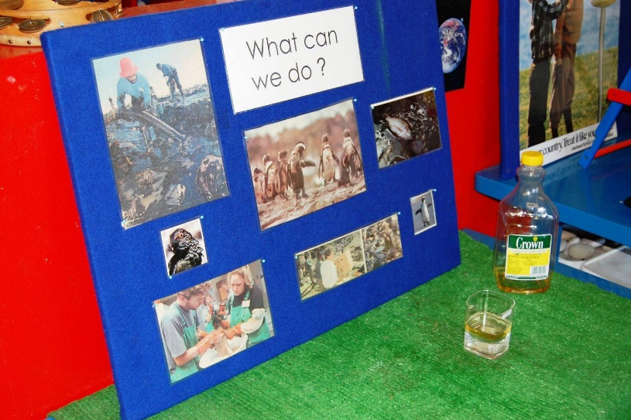
Extensions are extra resources that are added or changed on a regular basis and often relate to the theme being presented. Extensions are a means of changing the environment slightly for the children and introducing new concepts. In this way, you are able to keep your environment stimulating for the children and move them from the familiar to the less familiar. The extensions do not necessarily need to be major changes, changing the colour of the cushion covers in the book area or a different theme related poster, can be all that is needed to spark children’s interest. Children are very visual in nature and are attracted by colours – use this wisely to create interest in the learning activities.

This is often the most neglected area as many ECD practitioners do not specifically set up learning activities outdoors. In many instances, there is basic equipment such as jungle gyms and a sandpit and only a few resources that seldom change. ECD practitioners often complain that the children are destructive outside but it is mostly because they are not being stimulated enough. The outdoor or garden area should be an extension of the classroom and should provide as many learning opportunities.

The essential elements for young children are sand, water, adventure play and movement exploration. If there is space – woodwork, a pet corner and a vegetable garden are also fantastic learning opportunities.

Important considerations
Age of the children
Babies need a safe, grassed area with minimal equipment so that they can lie and enjoy fresh air and crawl around. It should not be too sunny and hot.

Toddlers need low climbing equipment, paved area for pushbikes, sand and water play.
In the table that follows, we will focus on the specific areas for young children

Safety
The area should be fenced; you should check that there are no poisonous plants; ensure there is soft ground covering under equipment and make sure there is no broken or rusting equipment. Large equipment needs to be firmly anchored in the ground and there needs to be constant supervision.

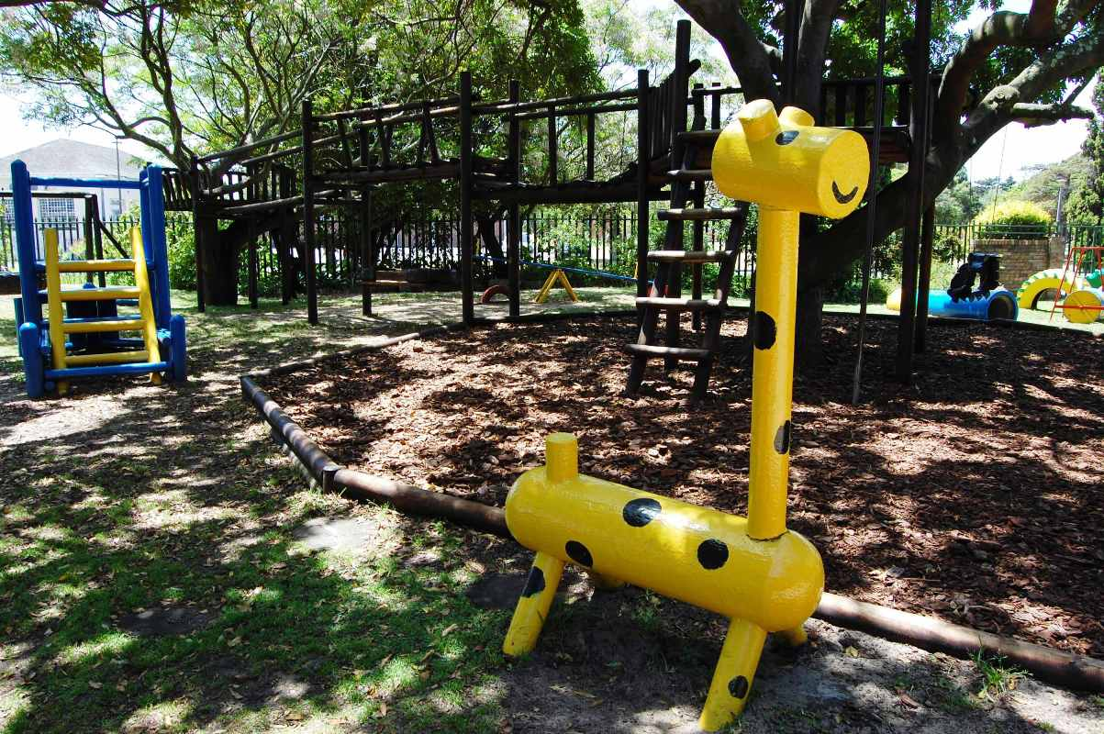
Rules

Children need to know how to use equipment safely e.g. no wheel toys on the jungle gym, no throwing of sand.

Space

There needs to be enough space around equipment like swings, so that children do not get hurt when walking past.
Light

The area should not be too sunny and hot, there must be shady areas (may be under a gazebo).

Variety of surfaces

There should be paved or tarred pathways or areas for wheel toys and grass.

Stimulation/noise

Not only is the outdoor area an active area where children are running around but there should also be quieter areas where children can relax.

Toilets

Need to be easily accessible as children often get engrossed in playing and only realise at the last minute that they need to go.

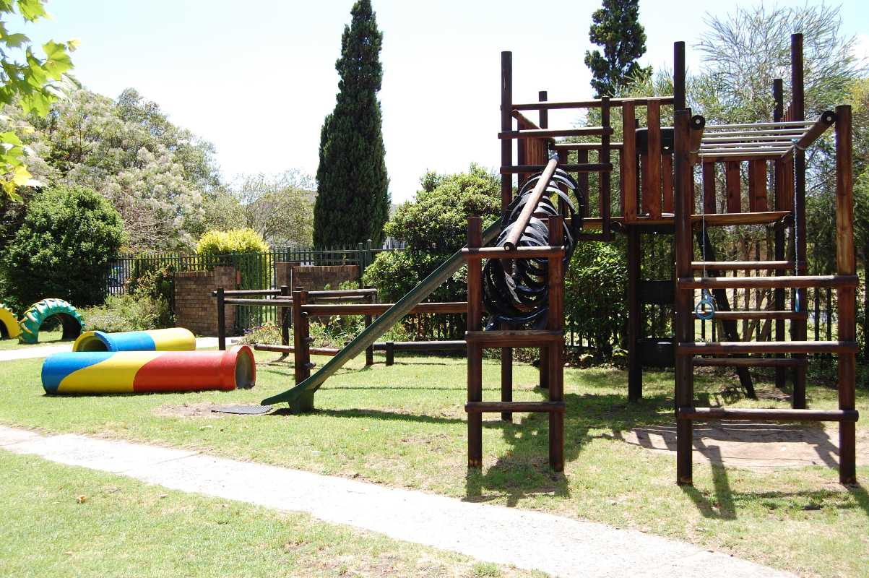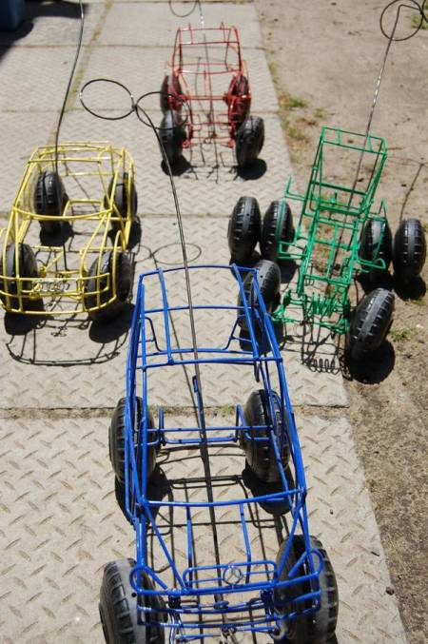

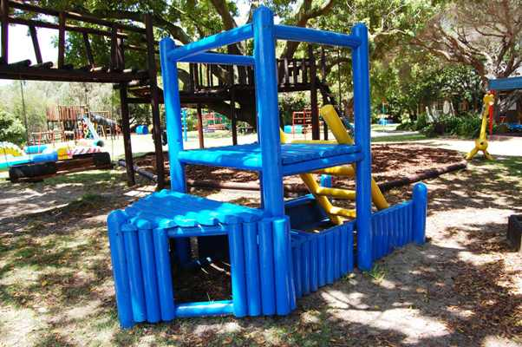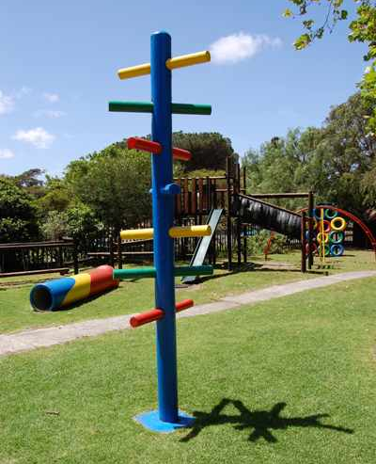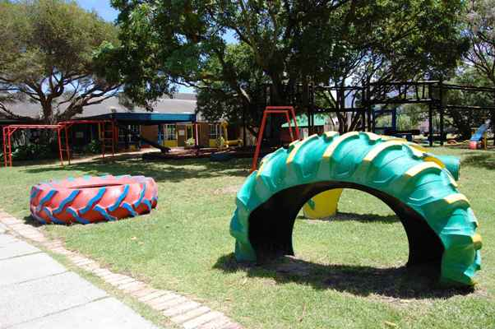

The outdoor area should include a variety of surfaces including grass and paved areas
Area | Basic furniture | Resources | Some extension ideas (usually theme related)
Water | Water trough or large basin that is not placed on the ground as this poses a drowning risk | Plastic items such as bottles, scoops, pipes, measuring cups, funnels, sponges etc  Items should ideally be colour coded with yellow, red, green and blue tape. They should also have holes on the bottom and sides in series from none to five. (This is such an important opportunity for children to learn maths skills)  Waterproof aprons ( can be made from plastic bags)  Water must be emptied out daily and fresh water provided | Sinking and floating – add boats  Colours – use dye or food colouring in the water  Add bubbles with nice smelling bubble bath or even dishwashing liquid  Add warm water in winter
Sand | Sandpit or container of sand, which is covered at night to prevent animals from soiling it  Must be large enough for children to climb into  Needs to have drainage if it is built in | Metal items such as tins, colanders, baking trays etc, must be painted, have no sharp edges and not be rusting. They should pose no danger to the children.  Plastic items bottles, scoops, pipes, measuring cups, funnels, spades, buckets, sieves, rakes etc  Balancing scale  As with water – they should have holes in them to provide opportunity for maths skills  Hardboard or plastic combs | Cars, plastic animals  Sea theme: hide shells for children to dig out  Water: wet sand is different to dry sand
Area | Basic furniture | Resources | Some extension ideas (usually theme related)
Adventure play | Grassed space  Paved area for wheel toys | Wheel toys –scooters, tricycles, bicycles, wheelbarrows, carts  Boxes, crates, drag boxes, blankets, shade cloth, pots, pans, hats etc (items for outdoor fantasy play) | Picnic: cooler bag with plastic plates, cups etc  Camping: sleeping bag, mattress  Beach: set up umbrella, towels, buckets, hats
Movement exploration | Fixed equipment such as swings, slides, jungle gym (wood preferably as it does not rust) – monkey bars, fireman’s pole, bridge, commando net, trapeze rings | Balance beam, balls, beanbags, bats, tyres, rope ladders, hula hoops, balance boards, punch bag, stilts, kick boards, tennequoit rings, swing ball, hopscotch | Set up a ‘tennis match” – hit ball over a net or piece of string  Spider’s web – use elastic around poles to create a web that they climb over and under
Wood | Woodwork bench or solid table | Real but miniature hammers and saws  Nails, glue, soft wood, wool, material, wood chips, sand paper, leather, pliers  This area needs CONSTANT supervision as the potential for a child to hurt himself is very high | Collage: glue different materials to wood pieces
Pet area | Depends on pet – must be secure so that pet cannot escape or be taken out without supervision | Tortoise, ducks, rabbits, hens  Area must be kept clean or they will attract rats and other vermin | Children can bring food for the pets  Petting time: under supervision of an adult
Vegetable garden | Quieter area of the garden where the risk of damage from balls and children running through is minimised | You can grow flowers, vegetables and herbs  Small spades  Trellises for beans | Use vegetable in foods presented to the children at lunch or snack  Use vegetables in make and bake activities

  - Stimulating and supporting early learning in a home environment

  - Concrete learning experiences

From birth to the age of three, children primarily use their senses to explore concrete objects. During this phase they have to see, hear, touch, taste and smell to learn.

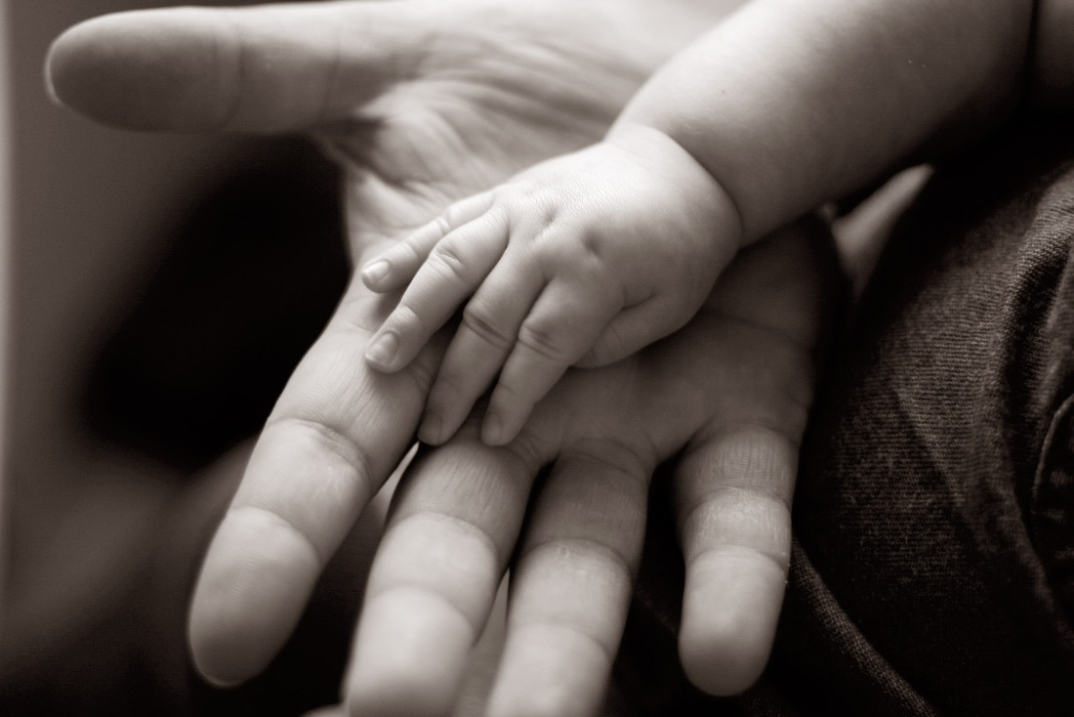

Babies use their senses to explore the world around them

    - Semi-Concrete learning experiences

Children between the ages of three and five years of age are able to relate pictures to the real objects that they explored earlier.

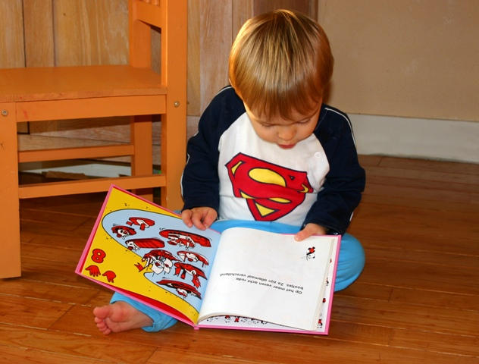

Children between the ages of three and five are able to relate to pictures of real objects

    - Abstract learning experiences

Children from age 5 can grasp the meaning of symbols and abstract concepts that cannot necessarily be explored by their senses.

It should however, be noted that although this is generally true, the learning process is like climbing steps. Once a particular skill is mastered it continues to be used during the phases that follow. For example the 5-year-old child that is capable of abstract learning still uses his/her sense of touch to explore the texture of new objects.

This knowledge will assist the ECD practitioner to make decisions regarding how to create activities that will specifically focus on the child’s developmental stage. For example, include objects of different textures in the baby room.

Raising awareness in families about child development
The good news is that children do not necessarily need expensive educational toys to enhance their early childhood development process. Parents can encourage development by learning some basic techniques. Try including an early childhood development tip in every newsletter you publish or put up tips on your centre’s notice board. When parents come to you for feedback sessions or meetings and mention problems that they have, you can help them by mentioning ways they can enhance their child’s development.

Children’s rights in South Africa
Our constitution stipulates the rights of children in South Africa. Let’s read through the children’s bill of rights together. In this section a child is a person under the age of 18 (The Constitution of the Republic of South Africa 1996, Section 28 of Act 108).

Every child has the right to:
- A name and nationality
- Family, parental or appropriate alternative care when necessary
- Basic nutrition, shelter, health and social services
- Protection from maltreatment, neglect, abuse or degradation
- Protection from exploitative labour practices for example: not to be expected to perform work or provide services that are inappropriate for the child’s age or place at the risk of the child’s education, physical or mental health or spiritual, moral or social development.
- If detention is unavoidable the child should be kept separately from persons over the age of 18, and the conditions of detention should take into account the child’s age
- Have a legal practitioner at the expense of the state
- Not to be used in direct armed conflict and to be protected in times of armed conflict

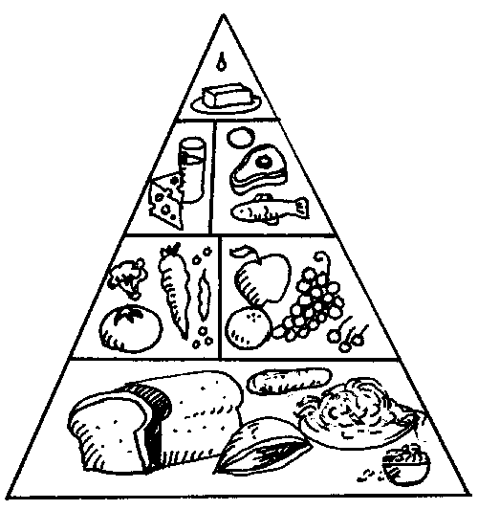

Every child has the right to basic nutrition. Good nutrition is met by following the basic food pyramid

The child’s right to education

The child has the right to:

- Basic education and to further education which the state must make progressively available and accessible
- Education in the official language or the language of their choice as far as practically possible and with taking into account equity, practicability and the need to redress results of past racially discriminatory laws and practices

Knowledge of these constitutional rights can assist the ECD practitioner to make a meaningful contribution through advocating and lobbying in the community for these rights. This means that the ECD practitioner can play a key role in making the parents and broader community aware of the fact that an early childhood education should not only be a priority, but the quality of that education is of utmost importance.

DID YOU KNOW?
Biblionef, an organisation based in Cape Town, distributes educational books to organisations and projects. They also commission books in mother tongue languages for young readers. They distribute a book called The Rights of the Child, which is available in all 11 languages. It also contains a summary of the Declaration of the Rights of the Child.
The cost of the book is R50.

Rights and responsibilities: A child’s perspective
below looks at some of the rights that children are entitled too, as well as the responsibilities that accompany these rights.

The rights of all children are: |  | The responsibilities of the child are:
1 | To enjoy the very best the world can offer | To look after the world s/he lives in i.e. not to litter
2 | To grow up in freedom and dignity | To give other children a chance to enjoy these freedoms too
3 | To have a name and a country of your own | To include/play with children across all cultures, races and countries
4 | To be fed when hungry and nursed when sick | To eat healthily and not to waste food
45 | To get special care if they are disabled in any way | To accept and support children who are disabled
6 | To have a family that loves and cares for them | To love and care for their own family or carers
7 | To go to school and not to have to work to earn money | To do their best at school
8 | To be helped in times of trouble and danger | To alert adults if they become aware of dangers
9 | To be protected from neglect, cruelty and abuse | To care for their own e.g. pets, younger siblings
10 | To be loved and in return spread peace and understanding | To show love and understanding to the people they meet
11 | To be encouraged and able to play | To play
Rights and responsibilities from a child’s perspective

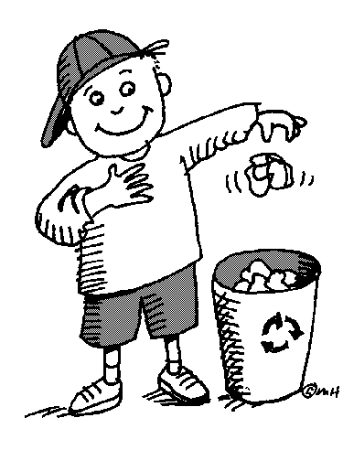
Children have the right to the best the world can offer, as well as the responsibility to help look after the world we live in

The role of the family in supporting child development and children’s rights

Young children learn by modelling behaviour. It is very important that parents are aware of this as they are the most important educators in the child’s life. Children learn how to process emotions, treat other people and handle conflict by watching their parents. The ECD centre can help to educate parents about their role in supporting child development and children’s rights and provide support for them to become more effective parents. Workshops on positive discipline, managing temper tantrums, or development phases could be hosted by the ECD centre. Short articles in the ECD centre’s newsletter could be of interest to the parents.

QUOTE
“Families are the core of society.” – slogan of Department of Social Services and Poverty Alleviation

How to approach families
Let’s look at how you can approach families in a sensitive, non-offensive yet effective way.

Create a complementary environment

You will need to create an environment at your ECD centre that complements the other aspects of the child’s life. The child’s learning experiences will be more integrated if there is a ‘cross-pollination’ between the home and the ECD centre. Ideally some rules, values, norms and discipline should to some extent overlap, so that the child will feel a sense of security and familiarity regarding the caregiver’s expectations. If there are too many differences, the environments may be more conflicting than complementary.

Get to know the children in your ECD centre

Observe the child and their families. Look at how the child and parents are dressed and whether they observe certain cultural or religious practices like prayers or dressing in a certain way.

Take time to talk to the family members as they bring or fetch the children; give them feedback about the day’s activities and use this time to gather more information about the child. Ask the children and their families about their specific traditions, and ways of living at home, what is allowed at home and what not, home routines and how discipline is enforced. This will most certainly offer a host of information about the child. Use this information to ensure that the ECD centre becomes an extension of home, rather than an entity on its own.

Building relationships with parents
Share information about the ECD centre’s routines and daily activities with the parents on an ongoing, informal and formal basis. Do this through making sure that the weekly themes, daily programmes, menu for the week and other important information is communicated in writing. Use a newsletter or the children’s message books.

Be sensitive to the fact that there might be parents who are illiterate or cannot read a specific language. In such cases, make sure that you communicate the information verbally or in the language of preference if at all possible.

Never underestimate the importance of informal chit-chat when parents come to pick up their children. People tend to be more open to sharing and building relationships when they feel relaxed and are in an informal environment.

Trends and behaviour awareness
As with most aspects of life, parenting also goes through stages and there are certain trends that become fashionable with regards to how to give birth, to breastfeed or not, how to potty train, or to use force while disciplining your child or not. You will observe these trends by monitoring the children and chatting to the parents. You can also enhance your knowledge of parenting trends by subscribing to a local parenting magazine. Place older copies of the magazines in the classroom for parents to read while waiting.

Being aware of adult and children’s behaviour is more important but also trickier than observing trends. One of your biggest challenges as an ECD practitioner is to always be on the lookout for children’s behaviour to look for any signs of unhappiness.

Especially look for any signs of:
- Emotional or physical abuse
- Illness, disability or affliction as loss of hearing, diabetes, or TB
- Learning disabilities

The family as a whole
When laying the groundwork for working with families, you should also remember to keep other family members in mind. Grandparents can be especially helpful as volunteers and storytellers at your ECD centre. Try to encourage the children to draw their whole family and to then tell you who everyone is. The more you get to know the children, parents and other members of families, the better you will know who to include in future events.

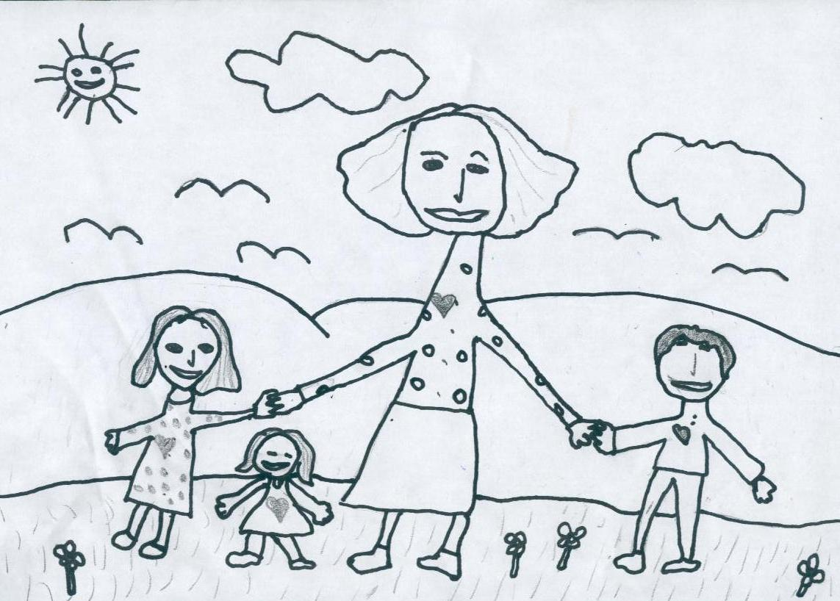

Encourage the children at your ECD centre to draw a picture of their family so that you can learn more about each child’s family as a whole.

FORMATIVE ASSESSMENT

• IAC0102 Explain key factors related to early childhood development setting, the environment and the broad needs of children

• IAC0104 Explain the key features of an effective play-based learning environment

SECTION 2: KM-03-KT02: Equality, diversity and inclusion in childhood development (30%)
Learning Outcome

At the end of this section, learners should cover:
- KT0201 Promotion of anti-bias practices and ensuring equality of opportunities
- KT0202 Importance of the child's first language
- KT0203 Promoting self-regulation

2.1 Promotion of anti-bias practices and ensuring equality of opportunities

What is bias?
When we are biased, we have a fixed opinion that is not based on fact. A bias is a belief, often based on erroneous information that can lead to the unjust, unkind, or unfair treatment of others. Some of the most common forms of bias and discrimination are racism, sexism and stereotyping.

- Racism: the discrimination against people because of their skin colour, race, religion, or national origin. People are viewed negatively and their abilities and behaviours are seen in a negative light.
- Sexism: the discrimination against someone on the basis of their gender. Society often categorise roles as either female or male. So girls are given dolls to play with and boys are given cars even though boys become fathers and women drive cars.
- Stereotypes: give the impression that all people who share some identifiable characteristic will behave in a certain similar manner. This is not a fact as all girls do not like wearing pink and not all people with disabilities need to use wheelchairs.

Bias–free activities
The activities you design for the children in your ECD centre should encourage children to look for the similarities between people, so we can find common ground and then celebrate the diversity. Even if two children are of the same gender and culture, it does not mean that they are the same!

What are the kinds of situations that might negatively affect a child’s self-concept or self-esteem?

Imagine …
- You are a little black or brown child, and all the pictures in your story books are of little white children, and the dolls you play with are all white or light skinned?
- You are Muslim, or Jewish or Hindu or follow traditional African religious beliefs, and at Christmas you hear Christmas stories and at Easter you make Easter eggs, but you never celebrate your own festival at your ECD centre?
- You are a Xhosa child and everything at your ECD centre happens in English?
- You are a little boy, and if you cry when you hurt yourself you are told that “cowboys don’t cry”?
- You are a little girl who loves to climb trees but you’re told that girls shouldn’t do that, and told to play with a doll instead?
- You are a child with a hearing disability and you cannot hear the stories, follow instructions, nor join in when your peers are laughing and playing?
- Your parents are divorced, but every time you talk about families the facilitator talks as though all children live in nuclear family structures?
- Your mother works to earn a living but the ECD facility assumes that all mothers are at home?

How to overcome bias and stereotyping
The best way to overcome bias and stereotyping is to create an ethos or atmosphere that honours and encourages diversity. The first step is to search your own heart: do you have hidden biases and prejudices? Do you favour certain languages, cultures, religions, family types and so on? Acknowledge your biases and learn to let go of them. Develop an inner attitude that encourages and nurtures the varieties and differences that make up the children in your playroom and in South Africa. With this attitude, you can use various strategies to make sure you have an anti-bias playroom. The article below provides some of these strategies:

Including diversity
The environment should reflect the importance of children by including examples of their work in progress, finished products, and by displaying images of children. Every child in the program must see examples of themselves and their family throughout the centre, not just in the playroom. Visual images are an important part of developing a feeling of belonging in all children, so it is important to display pictures of single parent families, grandparent families, and homes of every race and ethnicity, including interracial, multiethnic, and adoptive families.
The entire centre should also reflect diversity throughout the world: race, ethnicity, languages (not just English and Afrikaans), art, gender roles, religious ceremonies, shelter, work, traditions, and customs. The goal is for children to be exposed to the rich diversity of the entire world (Wardle, 1992). This is done through artwork, photos, posters, and signs on the wall; books; dolls; parent boards, newsletters, announcements, and magazines; and curricula materials such as puzzles, people sets, activity books, music, art materials, artifacts in the dramatic play area, and fabrics.

– Francis Wardle

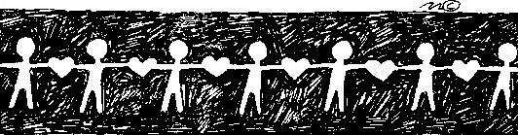
Bias-free activities can:
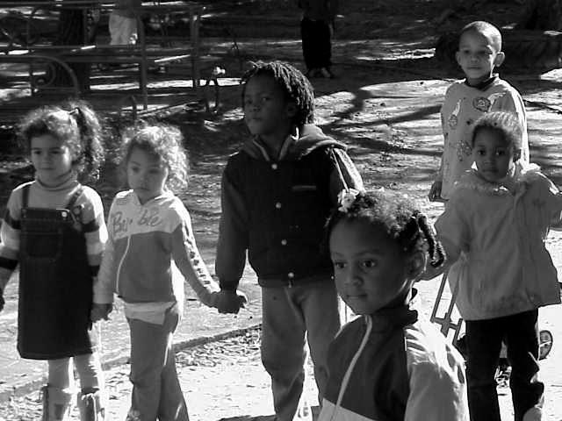
- Portray differences positively, and in so doing, foster respect for one another
- Stress similarities so we can cooperate on mutual interests
- Develop an understanding and sensitivity about culture, race, gender and disability
- Encourage children to respond to all people positively
- Develop the skills and capabilities in all children so that they can play a positive role in our diverse society

Morning ring ideas

- Greetings and greeting songs in different languages
- You can have discussions with the children about themselves and their families. This often occurs quite naturally when children tell each other their news. You can lead conversations by asking: What occupations do members of the family have? What hobbies do family members have? What is the make-up of each child's family? What are the extended family ties? What holidays are celebrated? What foods are typically served? Who joins the family for celebrations? What religion is observed (if any)? What is the child's house like? Where do they live? Who lives there with them? Do children of both sexes participate in a variety of extra-curricular activities? For example, do boys and girls do ballet and practise their ball skills?
- Use photographs of amputees on skis and basketball players in wheelchairs to initiate discussions. Introduce the concept of people being 'differently-abled' rather than disabled.
- Invite visitors who will challenge conventional stereotypical roles to give talks in your playroom, for example a male nurse, a female police officer or a disabled athlete.

Creative activities

- Often cultures have typical forms of art. Children can be encouraged to look at books and different types of art – noting the use of patterns, the colours, the symbols etc.
- When doing collages of people, the magazines need to have representation of all races and genders
- Avoid stereotyping – don’t ask girls to draw pictures of dolls and boys of cars
- Make-and-bake – get simple recipes from cultures represented in your ECD centre and use them to make during these sessions so that the children can learn about different foods
Music

- Introduce music from various cultures and show children pictures of instruments that may typically be used to make the music
- Sing songs in different languages
- Teach the children simple dances or hand movements from various cultures

Movement

- Children change places with 'different' classmates, for example, sighted children can wear blindfolds or physically mobile children may spend time trying to manoeuvre a wheelchair. This gives the children a chance to experience different lifestyles and to develop empathy with the frustrations.

Story

Illustrations and characters in storybooks have a profound impact on young children. Children add the information stories and books convey, to their store of knowledge, and use them as a basis for perceptions about the world around them.

Look at the books and stories (and illustrations) you use in your playroom – do they:

- Have pictures of children of different races (in SA, the majority should be black to really reflect our culture)?
- Include disabled children and adults in a leading/positive way?
- Show different cultures and religions in a positive way?
- Show different financial backgrounds, positively (most South African families are not wealthy and do not live in big houses)?
- Allow for aspirations, in terms of representing, for example, black families as wealthy, even though this is not the norm for black people in South Africa?
- Show girls doing things like playing on bikes and leading adventures, and women working outside the home or being the head of the household?
- Show boys doing things like looking after younger children and being gentle, and men working in the home and taking on a caring role?
- Have authentic and accurate representations or realistic characters, not just stereotypes?

Fortunately, we are no longer restricted by the books that are available to us. In the past, we had very few locally published books that celebrated diversity and portrayed characters that were from different cultures and races or were set within a context that young children could identify with. This was alienating for many children and had negative effects on their self-esteem and self-image. Books and stories should affirm the uniqueness of children.

- Stories and books about different cultures – the food they eat, the language they speak, the clothes they wear etc. All Kinds of Families by Norma Simon (Albert Whitman & Company, 1987), Black is Brown is Tan written by Arnold Adoff and illustrated by Emily Arnold McCully (Amistad Books, 2004), Horns Only written by Fathima Dada and Leoni Hofmeyr and illustrated by Heather Moore and Jiggs Snaddon-Wood (Maskew Miller Longman, 2002), The Cool Nguni written by Maryanne Bester and illustrated by Shayle Bester (Jacana Media, 2007).
- Stories and books about children with disabilities – their daily lives, their interests and ambitions e.g. Andy and His Yellow Frisbee by Mary Thompson (about a boy with autism), Don't Call Me Special – A First Look at Disability written by Pat Thomas and illustrated by Lesley Harker (Hodder Wayland, 2002)
- Stories and books that challenge traditional gender roles e.g. When Dad Did the Washing by Ronda Armitage, My Mommy Wears Army Boots by Verna Harps-Morrow.

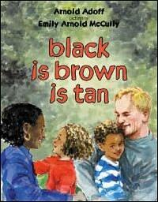

Black is brown is tan by Arnold Adoff and illustrated by Emily Arnold McCully

Meals

- Prayers or grace said or sung in various languages. Avoid the use of God or Jesus in the grace. It may be best to speak to parents about the religious beliefs and practices to ensure that you do not cause offence e.g. Muslims pray with open hands unlike Christians. It may be best to use a very generic blessing, which has no religious bias.
- Discussions on food – especially if children provide their own snacks. You could learn about different cultures by the food children bring.
- If food is provided by the ECD centre, try to persuade the kitchen staff to prepare items that cross boundaries e.g. vegetarian samoosas for a snack.

Toileting

- Always consult parents about these practices as they may differ e.g. Muslim girls are taught to wash themselves after using the toilet and will need a jug of water next to the toilet to pour over their genital area.

When in doubt – ask a parent or colleague of the same culture or do some research – remember that “assumptions are the mothers of all misunderstandings”.

Every child has the right to be cared for; to be protected from violence and abuse; to participate and make decisions according to their age and stage of development; the right to have their say and be heard; the right to education and play; the right to survival and development; and the right to rehabilitation and care. In this topic, we discuss the various documents that help to promote and protect these rights. We also discuss how we can educate children about their rights, according to their stage of development.

DEFINITION

Rehabilitation means that things are done to put life back to normal.

Laws and regulations that protect children’s rights

The table below explains the main documents that protect and promote children’s rights.

Document | How children’s rights are protected and promoted
The South African Constitution | The Bill of Rights in the Constitution says:  - Children have the right to a name, citizenship and some form of care.  - Children have a right to food and shelter.  - Children should be protected from abuse, neglect and degradation.  - No child should work when under-age, or do work that would interfere with his or her education or development.
The Child Care Act and Regulations | According to this Act parents have the responsibility to provide their children with:  - A suitable place to live  - Financial support  - Protection from abuse, neglect and harm  - Help with their upbringing and education  - Assistance in making good decisions.  Children have a right to dignity and freedom and security of person.  The Children’s Act protects children by:  Establishing a National Child Protection Register that contains information about abuse or suspected abuse of children. This register includes the names of persons who are unsuitable to work with children because they have committed abuse towards children.
The United Nations Convention on the Rights and Welfare of the Child (CRC) | In 1989 the United Nations (UN) member countries formulated the Convention on the Rights of the Child (CRC) on how to protect children from discrimination, neglect and abuse. The CRC is now the main agreement that the world, each nation, and all people have with all the children of the world.  The CRC promises children the following:  - The right to an adequate standard of living  - The right to enjoy a high standard of health  - The right to education  - The right to protection from violence, abuse, neglect and exploitation  - The right to special care, special protection and assistance  - The right to a safe environment  - The right to participation
Department of Social Development minimum norms and standards for ECD Services | The Department of Social Development is involved in a number of projects that fight child abuse and neglect. The Department has also developed minimum norms and standards for Early Childhood Development services.
Childline South Africa | Childline offers a toll-free crisis line  (0800 55 555) to children and families across South Africa on a 24-hour basis. The line provides immediate assistance to children and families in crisis who need counselling and information.  Apart from the 24-hour toll-free helpline, services also include treatment centres for individual, family and play therapy; prevention programmes; community safe houses; and training and awareness programmes.
Children’s Charter of South Africa | In 1992 an international conference was held in South Africa about the rights of children. Over 200 children between the ages of 12 and 16 years came to this conference from 20 different regions in South Africa. They discussed the problems they face. At this conference the children drew up the first Children’s Charter of South Africa. Here are a few of the general rights that were written into this charter:  General rights  - All children have the right to be protected against all forms of discrimination.  - All children have the right to a name and nationality as soon as they are born.  - All children have the right to express their own opinions and have the right to be heard.  - All children have the right to be protected from all types of violence at home, at school, on the streets, and in townships and communities.  - All children have the right to be protected from neglect and abandonment.
Documents that protect children’s rights
The above rights are summed up in the following list that is put out by the South African Police (SAPS). According to this list, we must teach children that they have the following rights:

- The right to a loving and caring family, a proper, safe and comfortable home, clothing and healthy food.
- The right to be told the house rules of where they live.
- The right not to be forced to work.
- The right to education.
- The right to a say in their care according to their age and maturity.
- The right to get special care for special needs.
- The right to be protected from hurt.
- The right to good health care.
- The right to be treated properly.
- The right to be taken seriously and to make mistakes.
- The right to their own religion and culture, and the right to be proud of their heritage and beliefs.
- The right to a name and nationality.
- The right to be treated the same, no matter what their colour, race, gender, language or religion.
- The right to speak and to be heard.
- The right to privacy.
- The right to own his or her own things.
- The right to speak in private with their family or any other person representing them like their social worker or lawyer.
- The right not to be put in prison or in a police cell.
- The right to know what their rights are.

Ideas on how to educate children about their rights
Children are the group in our society who are most vulnerable or open to being abused. Infants, toddlers and young children can seldom protect themselves from older and stronger adults, or keep themselves safe. So it is our responsibility as adults to promote children’s rights and to protect them from all forms of abuse.

But from as young an age as possible, children should learn that they have rights and that as they grow older they can they take more responsibility for their own safety and well-being. The more they know and understand their rights, the less chance they have of being abused. Our challenge is to find appropriate ways to teach children about their rights – appropriate to their age and stage of development.

Some appropriate ways to teach children about their rights include:

- Using and talking about pictures
- Role-playing different situations
- Action songs
- Puppet shows
- Drawings.

One of the first things we can teach children about their rights is how to recognise and express their feelings.

Teaching children about feelings
Young children often struggle to recognise and express their feelings and emotions. This is especially true when they feel unhappy, fearful or angry. In addition, children often don’t have the words to talk about what they’re feeling. However, learning to express feelings is an important part of development, as well as an important part of recovering from a traumatic event, like exposure to violence or abuse. As an ECD practitioner, you can help children learn to recognise and express their feelings through games and other activities that don’t rely on using words. You can also help children to learn the words that describe their emotions. Often when a feeling is given a name, it becomes less scary and easier to manage.

Circle discussion

Have the children sit in a circle in a comfortable place. Have a discussion with them, in which you explain that adults and children have many different kinds of feelings, and that to have feelings is perfectly normal. Tell the children that it is important to learn healthy ways of expressing (showing) our feelings. Ask each child to name an example of a feeling, such as happy, angry, bored, excited, embarrassed, frightened and so on. Once a feeling has been named, ask all the children to act out the feeling or make a face showing that feeling. Ask the children if any of them would like to tell the group about a time when they experienced that feeling.

This activity will broaden the children’s knowledge of the range of feelings that can be recognised, as well as the names for these feelings. It will also make them aware that chatting about how you feel is normal and acceptable, and that feelings are not something to be hidden

Respect and sensitivity for culture and ability

It will help your facilitation skills if you know a little about each child’s culture in their family of origin or their caregiver’s family. It is useful to know about their home language, religious beliefs, cultural celebrations and lifestyle. This should form the foundation of your sensitivity to the child’s culture. Stay respectful in your behaviour, by avoiding the use of discriminatory language, slang or culturally biased remarks, and keep in mind that the culture of the ECD centre may not match the home culture of the child.

This gap may affect the child’s performance of tasks at the appropriate developmental level, because of language difficulties or attitudes to tasks. Some families may emphasise the importance of physical abilities and expect the child to do chores like cleaning shoes, helping to make sandwiches for school snacks, and making the bed, while other families may emphasise language abilities and may promote reading and storytelling at home, while not worrying too much about the child’s practical skills like competent shoe-cleaning. There will always be things about the child’s background that you may not know, so stay flexible and respectful, and be willing to get to know the child slowly.

Being sensitive to disability

Not only culture, but also ability (or disability) may be a source of discrimination at the ECD centre. More and more children with physical disabilities are being integrated into mainstream classrooms as this provides good learning opportunities for both the disabled child and his or her peers. Your ECD centre may already include a child who has sight or hearing impairment or who is physically disabled in some other way. The children’s acceptance of the disabled child depends on your own acceptance and the atmosphere created by your management of their special needs.

Steps toward working without bias

There are three steps towards working without bias and in using teachable moments to reinforce cultural acceptance.

Step 1: Facilitators should develop their own awareness of bias

Facilitators should have a monthly anti-bias consciousness-raising group, in which they explore their own cultural identity and also talk freely and openly about which cultural characteristics of other people (children at the ECD centre, their parents or even fellow facilitators) makes them feel uncomfortable. The following questions may be helpful to structure such a discussion:

- How do I describe my own cultural identity?
- What is it in another culture that makes me uncomfortable in any way?
- What has happened in the past when I witnessed biased behaviour – how did I respond?
- By exploring these issues together, facilitators should aim to become more self-aware and to eliminate bias in their practice.

Step 2: Explore and enlarge the children’s input about diversity

It is also helpful to dip into the children’s awareness of diversity, to get ideas about what matters to them about cultural differences. Sometimes children focus on aspects of cultural difference that adults do not notice; sometimes children are much less concerned about differences than adults are.

Use a story book, a glove puppet or an example of a person in the environment to open up the topic for discussion.

Example of sensitive handling of differences in culture or ability
Facilitator to the group (showing pictures in a book, or using a glove puppet): Here’s a picture of Alex, I see he has one leg shorter than the other. He wears a special thick shoe so that he can walk without limping.
Mimi: He’s lucky his mom sorts out his shoes for him. He can still run, hey?
Facilitator: Mmm – and if he can’t run fast, what then?
Sam: Well, some children will tease him but surely he can walk alright? He could play cricket with us. And he could even come on our Spring Walk.
Facilitator: And when he takes his shoes off and plays in the sandpit, what then?
Mimi: Well, I would like to see his funny foot. Maybe it’s different from mine. Maybe it’s like an animal’s foot!
Khaya: But I could help him get into the sandpit with his bare feet.
Facilitator: That would be kind, Khaya. How do you all think he might feel if someone said he had a ‘funny foot’?
Khaya: He … he would feel sad.
Mimi: He would feel… ugly.
Facilitator: It’s okay to look at something if you are curious. But when you talk about something that is strange, it’s kinder to call things by their ordinary names. His foot is not different, but his leg is different. How would you talk about his leg? What kind of leg is it?
Mimi: It’s just a short leg. Okay, he can come in the sandpit with his short leg.

The children’s answers will pinpoint the issue of where the differences matter. Your response as the facilitator should then work to draw a constructive picture about those differences, making them familiar, manageable and acceptable, so that they no longer seem threatening or strange.

It is important to have materials in your book area showing images of people from different cultures and from different ethnic groups, as well as stories and images of people with disabilities in everyday settings. Be sure to include these books and pictures in your playgroup, and perhaps set aside some of your book budget especially for this need. As a general rule, the ECD centre’s books and materials should not show bias or stereotypes.

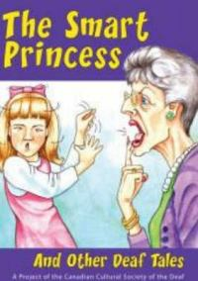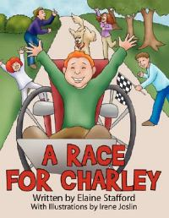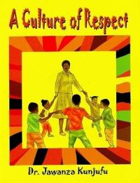

Examples of books that you could include in your book area around the subject of diversity

Step 3: Draw the parents and their culture into the playgroup

The second step, after raising awareness, is to begin to work actively and practically with the parents. By getting to know them, you will familiarise yourself with their cultural background, and be better able to address bias and cultural differences at the ECD centre.

Invite parents to bring a special object from home, some culturally-specific item (like books, pictures, cultural items like dolls, jewellery or beadwork, clothing, musical instruments, pottery or household items, or special festival food) and have a week to display them and discuss them at circle time. Invite the child whose culture is being discussed, to say something or tell a story about the use or importance of the object, and what he or she can remember about its role in his family. Parents could also contribute items that could stay at the ECD centre (like books or pictures, or they could make their child’s apron from traditional cloth) to help make the environment more familiar and an extension of home.

It is also a good idea to invite a parent who has a different home language, to attend story time or circle time with the group. The parent can participate by listening and retelling or explaining the story in that language, to children with the same home language. They could also bring a story to tell in that language, tell the story, then explain or describe this in English if possible so that you can retell it to the rest of the group. The children who are familiar with that language can also share and describe their understanding to other children in English if they can, which is good language practise and promotes inclusivity. In this way you facilitate for cultural diversity, using the parents as a resource.

QUOTE
“We all should know that diversity makes for a rich tapestry, and we must understand that all the threads of the tapestry are equal in value no matter what their color.” – Maya Angelou

A good opportunity for teaching equality and inclusivity may arise when a new child joins the ECD centre with some difference that provokes questions or comments from the children. This represents a teachable moment for anti-bias education. You should use this opportunity to show caring, understanding, sensitivity and compassion to the child. For example, a child who has a birthmark on his face, or a parent who is disabled, will be a talking point. It is best to deal with this honestly and immediately, to improve knowledge and understanding at the peak of the children’s curiosity about the difference, and to cut out any possibility of hurtful behaviour from the children. Try to answer the children’s questions fully and sincerely, drawing upon your new awareness from Step 1. Your calm example will help to normalise the situation.

Gender issues are another talking point. Try to include books, materials and visitors to show how everyone should be able to do everything (for example, women who are long-distance truck drivers and men who are nurses). The more everyday real examples of equality and flexible gender roles you can show the children, the better. You could also invite a visitor to talk to the children about their gender-flexible work role (for example, a woman horse trainer or a male florist).

In the same way that you feed the children anti-bias information, you need to share this information with the parents, through newsletters and parents’ evenings. Use parents’ evenings to tell a story or two about discussions you’ve had with the children, to highlight the aim of your ECD centre to be inclusive and accepting of differences. On a more formal note, you could arrange a special focus evening with a talk for parents on how children develop identity and attitudes. This could be a source of a new skill for parents, to deal with bias and cultural differences sensitively at home when their children ask questions or identify a difference as a talking point. Your staff support group should continue to feed your awareness and personal growth on these issues, but your group should also evaluate the programme at regular intervals.

Anti-bias as the foundation of your approach
Finally, an anti-bias approach should become a normal and natural part of your work. Any comments, questions or expressions of fear from the children about differences, could be used as teachable moments within your activities, for the whole group. Try to develop more new activities for the children, using the children’s questions as starting points for games about inclusiveness and acceptance.

2.2. Importance of the child's first language
First, learning does not begin in school. Learning starts at home in the learners’ home language. Although the start of school is a continuation of this learning, it also presents significant changes in the mode of education. The school system structures and controls the content and delivery of a pre-determined curriculum where previously the child was learning from experience.

On starting school, children find themselves in a new physical environment. The classroom is new, most of the classmates are strangers, the centre of authority (the teacher) is a stranger too. The structured way of learning is also new. If, in addition to these things, there is an abrupt change in the language of interaction, then the situation can get quite complicated. Indeed, it can negatively affect a child’s progress. However, by using the learners’ home language, schools can help children navigate the new environment and bridge their learning at school with the experience they bring from home.

Second, by using the learners’ home language, learners are more likely to engage in the learning process. The interactive learner-centred approach – recommended by all educationalists – thrives in an environment where learners are sufficiently proficient in the language of instruction. It allows learners to make suggestions, ask questions, answer questions and create and communicate new knowledge with enthusiasm. It gives learners confidence and helps to affirm their cultural identity. This in turn has a positive impact on the way learners see the relevance of school to their lives. But when learners start school in a language that is still new to them, it leads to a teacher-centred approach and reinforces passiveness and silence in classrooms. This in turn suppresses young learners’ potential and liberty to express themselves freely. It dulls the enthusiasm of young minds, inhibits their creativity, and makes the learning experience unpleasant. All of which is bound to have a negative effect on learning outcomes.

2.3 Promoting self-regulation

Parents, guardians and caregivers are a child’s first role models and educators. Through their words and actions, they teach children about themselves, about relationships with others, and about children’s rights. Through their words and actions, parents and caregivers need to show that they are responsible for protecting their children and promoting their rights. You can play a role in helping parents and families become aware of these responsibilities. In this topic we will discuss some ideas of how to do this.

Keep families informed
It is important to keep parents and guardians informed about what is happening in the ECD programme so that they know what their children are learning in the centre and so that they can reinforce this learning at home. You can keep families informed in the following ways:

- Create a notice board to highlight the week's events and themes. Make suggestions about what parents can do at home to reinforce the themes.

Building self-esteem
Self-esteem is the essential ingredient in human beings that increases personal growth, happiness and development on all levels.

By showing warmth, respect, responsiveness, and sensitivity to the individual, their context and their needs, the facilitator can promote the development of the children in his or her care. The facilitator’s warm and caring attitude is the fertiliser that grows the child’s self-esteem.

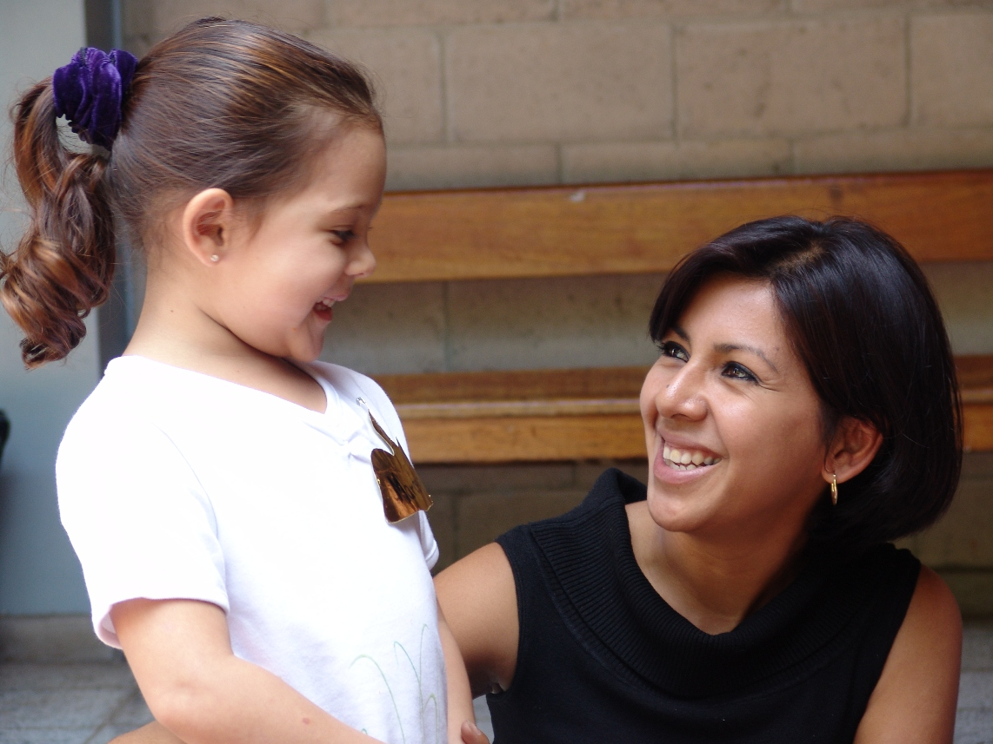

A nurturing and emotionally warm tone in your approach to the children in your care, you provide a fertile foundation for their sense of security and self-acceptance.

Beware of the vulnerable child

Think of the child as a vulnerable plant that will bend and wilt if it hears unkind words. Try to speak kindly at all times. If you must raise your voice, do it only occasionally – think how much you dislike it when you have shouted at in the past. Show warmth in the way you speak, use a bit of humour to show you are understanding, and avoid using negative terms such as “Don’t hesitate! Don’t be stupid! Can’t you understand?” or labels and judgements like “You’re so clumsy!” Model tolerance, patience and kindness in all your behaviours, and the children will learn to communicate in the same way.

Communication to promote development

Good communication is more effective if you address the child by his name. This gets his attention and makes him feel valued. Also aim to remember little things he has done well before, and bring these up as reminders to encourage him when he needs it. For example “Sipho, I see you’re trying that new puzzle – I remember you did the other one all by yourself last week. Well done for trying this more difficult one.”

Attend and listen, be emotionally available

Begin by focusing on the child, making an inner decision to listen with your full attention, stop what you are doing and tune in for the emotional message the child may be giving. Acknowledge the child’s feelings. Do not immediately become solution-focused; first be listening-focused. Respect and allow the feelings, by giving the child the opportunity to cry, express anger or whatever he might need to say. This is being empathic.

Encourage the child to trust his feelings. Only after this full expression of feelings has taken place, should you support the child to problem-solve towards a solution that works for him. It is not your role to create solutions. Your listening increases the child’s sense of his worth, and your validation of his feelings allows him to move on to the next step, which is problem-solving in his own way for his preferred outcome.

Manage conflict firmly and reasonably

Try to be accepting of storms and tantrums and use the opportunity to acknowledge feelings first and restore boundaries for behaviour second. Try to stay friendly and understanding. Accept children’s questions about the boundaries or rules, and be firm but reasonable. The simple act of your answering the question tells the child that he matters. When you must discipline or set firm limits, it must be for a practical reason that the child can understand, not just “Because I say so”. Provide clear boundaries, guidance, love and positive discipline, and conflict will be minimised. Such clear boundaries teach children to care about themselves and others.


Praise something specific

Stay focused on giving positive feedback and simply drop the negative from your vocabulary. Look at specific instances and give praise immediately where appropriate. Don’t just say “That’s good” or “You shared nicely today”. Instead notice what the child is contributing to his work or the social situation, and praise a feature of his effort, for example “I noticed how you waited quietly for your turn. You were very patient.” or “I see you’ve managed to fit all the blocks back into the box without a single one missing – well done for being so careful”. However, even a general “Well done!’ is better than no praise at all.

Avoid creating expectations that the child cannot meet, when you say things like “You’re the star tidier in our group” or “Let’s ask our clever one for news about the weather today”. These grand labels put pressure on the child and he may not always want to be the one responsible for tidying up or answering the weather questions. Also avoid general commands to “Be good”; make your expectations specific and manageable on a once-off basis. A helpful way to praise the child is to be specific about the activity, for example “I hope you can help me mix the paint today Joseph, I need a steady hand.”

Steering the process: from feelings to fixing up

When children do misbehave, do not pretend to ignore the behaviour, simply acknowledge the feeling that may be expressed (“It sounds as if you’re really very angry about Ray spilling paint on your shoe”) and then address the behaviour with encouragement to do something positive, for example, “What could you ask Ray to do to make it better?” or remind about the limits, for example, “You seem really angry with Ray… but we have a rule of no hitting. Instead of hitting you can tell him how you feel” or “…and now see if Ray will help to clean it up” and “….and now it would help the two of you to be friends again, if you could say sorry to Ray for hitting him”.

Always take the time to mend a quarrel, especially if the children are about to go home. It is helpful to sit down with the children involved and encourage them to work things out, possibly (not always) reaching a point where they can forgive each other. Again, show empathy for the feelings, then remind them about the limits for behaviour.

Show some physical affection

Show your warm feelings to the children with hugs, holding their hands, putting a hand on their shoulders, saying you like having them around, showing that you appreciate them. Babies need the comfort of touch and cuddles in order to grow, and everyone needs affection. The human touch is extremely healing and powerful. This affection will keep them supported and motivated and increase their sense of freedom because they will feel secure in your presence.
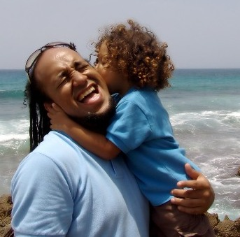

Showing your affection is an important part of nurturing the children at your ECD centre

FORMATIVE ASSESSMENT
- IAC0202 Describe how to enable children to develop sense of identity and self-worth
- IAC0204 Describe potential barriers to implementing equality in early-years settings
- IAC0206 Describe the various interventions that promote positive child behaviour
- IAC0208 Describe the indicators of children in need of additional support
- IAC0210 Describe how early interactions and discussions affect later levels of thinking and reasoning

SECTION 3: KM-03-KT03: Early Childhood Development Programmes (35%)
Learning Outcome

At the end of this section, learners should cover:
- KT0301 Early Childhood Development-related programmes
- KT0302 Daily programme/daily routines, including design of activities, routines and transitions
- KT0303 Programme planning and evaluation
- KT0304 Uses of information technology with children

Early Childhood Development-related programmes
Learning activities
The diagram below illustrates a variety of activities that we plan for in a typical ECD setting for toddlers and young children. In this unit we are going to look at each developmental area and list possible activities that can be presented to develop related skills. Many of the activities we will discuss are relevant to more than one developmental area. These are integrated activities, for instance completing a puzzle is a cognitive skill, but it also involves fine motor skills in order to manipulate the pieces into place.

The main domains of development

Activities for physical development
These skills can be further categorised in gross motor (using the large muscles of the body to run, jump, bend etc) and fine motor skills (using the fingers for pencil grip, manipulating small items like pegs).
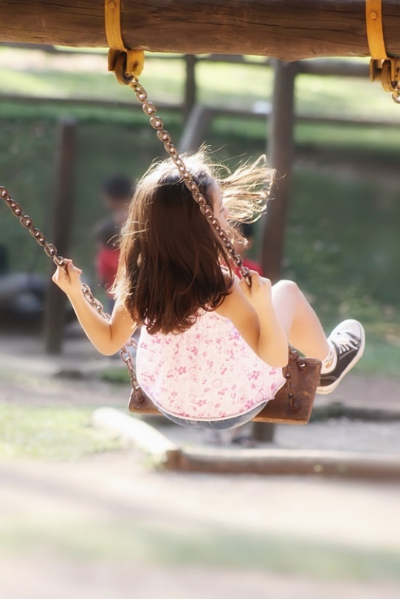
Gross motor activities
These skills include crawling, climbing, balancing, swinging, hanging, running, skipping, bouncing, throwing and dancing and are most often addressed in:

- Music rings – free responses and move to music
- Movement activities – these are thoroughly covered in Unit 3

Gross motor activities do not always have to take place outside – sometimes children need to expend a little energy between activities.

You can use the following ideas as introductions to other activities, expanded to be a full movement ring or as fun while during transition times.

- Animal imitations: sit in a circle – call out the names of different animals. The children then have to imitate that animal – snakes slithering, zebras galloping etc.
- Hopscotch: use chalk to draw hopscotch in the sand, on a pathway or even a carpet indoors.
- Imaginative walks: take the children on a pretend walk. You can encourage their input by asking what they can see. You can then dramatise this and add actions. Children may say they see a car – everyone can then pretend to drive a car and run around the room, stopping for red robots.
- Dramatise stories; a great book to use as a basis is We're Going on a Bear Hunt by Helen Oxenbury
- Action songs, e.g. Hokey Pokey

Activities for fine motor skills development

Activities we prepare would often be art or “make and bake”.

Here are other ideas that can be used in art or as parts of other activities:
- Fingerplays
- Bead threading – can also use straws that are cut into shorter lengths as beads
- Puzzles
- Use of tools – these include cookie cutters, blunt needles, scissors etc
- Construction games – Lego, Meccano, Tinkertoy, Lazy and Dizzy Discs

Activities for cognitive development


Educational toys and games can be used as conclusions to stories or other rings to reinforce ideas.
- Matching games like lotto, dominoes, simple cut out puzzles
- Memory games – snap, Kim’s game or ‘what’s missing?’, matching sounds to
pictures in Look and Listen games
- Sorting games – according to shape, colour, size, type etc.
- Sequencing and patterns – questions like ‘what comes next?’

Activities for language development
There are many ways to encourage language development in an ECD setting as almost all activities rely on language. Children will spend their time either listening (actively or passively) or speaking in routine and learning activities. You can provide children with activities that develop their oral and listening skills and increase their vocabularies during any activity.

- Listening activities – identifying sounds in and around the ECD centre, identifying a musical instrument when it is hidden behind a screen and played for them.
- Ask open-ended questions – can be used at the end of stories and right through the day e.g. “what would you like to draw?”
- Encourage conversations – good time is at meals and snacks when we naturally chat about things. Try to draw some of the quieter children into conversations by asking them questions that they will feel confident of answering, about their families or pets or food preferences. An ECD playgroup should not be silent. You can encourage children to share their feelings or ideas with others by making comments such as “Why don't you tell Nomsa about that?” or “Ask Sarah about her new baby brother.”
- Simon says – good listening activity and can include lots of gross motor activities too.
- Act out emotions and feelings – it teaches children to read body language

Activities for social and emotional development
Children are very egocentric to begin with and only really move out of parallel play after three years of age. However, it is critical that children learn to socialise and display pro-social behaviours such as sharing and respect. Many ECD activities are arranged in groups and so children need to be able to work together at various times in the day. Your task, as the ECD practitioner, is to encourage young children to communicate, interact and collaborate together, so that they can develop their social and emotional skills.

- Set up activities in which the children are required to work together – such as games like dominoes, or set up art activities for groups of four where they have to share tools like scissors.
- Use routine-based activities like morning ring or hand washing to teach and reinforce social skills like turn-taking.

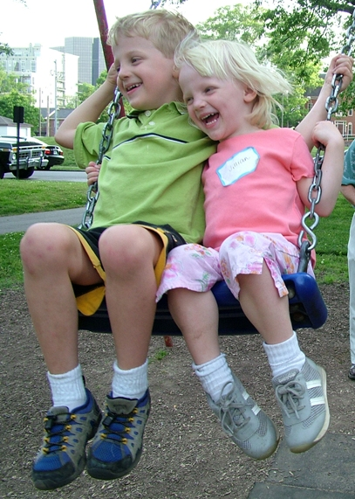
Social and emotional development includes sharing and turn-taking

Activities for creative and imaginative development
- Make sure that you encourage children to follow their own interests. Encourage them to use their imaginations express their interests in their creations rather than tell them what to draw or paint.

- Encourage children to select their own materials and tools. They may want to paint with their fingers rather than use a paintbrush or they may want to cut their paper into a shape before painting a picture. We should encourage this expression of creativity and facilitate it by providing a range of tools and not imposing too many rules. We sometimes are so intent on sticking to our goals that we force children to do as we say and lose out on “teachable moments” or inspired ideas. As ECD practitioners, we need to let the children lead us sometimes.
- You need to present a wide range of art activities (at least three a day). Art activities can include drawing, painting, construction, printing, modelling and collage in a number of variations.
- Encourage children to express their own ideas in their own way. Let them draw and paint their own pictures rather than do worksheets or colour in your pictures.
- Provide children with inspiration. You could play music while children participate in a creative art activity, allowing the music to influence their moods and enhance their creativity. Encourage them to “paint what they hear”.
- Act out familiar stories using props. Don’t stress if they change the story or characters. Better yet, let them act out their own stories.
- Start a ring with “once upon a time there was….” and go around the group allowing the children to add on to each other’s ideas until you end the story.

 | Babies | Toddlers | Young Children
Gross Motors
Fine Motors
Cognitive
 | Babies | Toddlers | Young Children
Language
Socials
Emotional

Children learn best when they are actively involved in an activity rather than being passive recipients and so it is important to include them as far as possible when you design activities.

Child input refers to any activity where the children contribute to the content, resources or process in a meaningful way. There is an old Chinese proverb that says, I hear and I forget. I see and I remember. I do and I understand. This illustrates the importance so well!

What value does their input have for the children?
- Children become more responsible about their work and the things in their environment
- Feel valued and see that their work or creations have value so they value them too
- Improved task completion as they are involved in activities they enjoy and that interest them
- Builds self-esteem
- Stimulates creativity

Useful strategies for including children
Here are some ideas on how to include children in a meaningful way in the learning activities. Children can be very resourceful and can help lighten your workload if you guide them. In this way, they help you but also derive great benefits – a win-win situation.

Self-directed activities

Where possible, children should be able to make their own decisions and initiate their own activities. Children do not get the opportunity to learn and grow if they are constantly being told what to do or follow the ECD practitioner. As adults, we seem to fear that by allowing children to make their own decisions, they will make poor choices, injure themselves or value us less. The opposite is in fact true. When we force children to do an activity, they resent it and may show this by behaving badly or being disruptive. When children are engaged in activities they enjoy, they become calmer and focus more.

The ECD practitioner should create opportunities for children to make suitable choices by controlling the environment. A well-planned ECD centre that is stimulating and has age appropriate activities will indirectly create a measure of control. This indirect external control will teach children to control themselves and they will learn to conduct themselves in appropriate ways. This does not mean that we merely stand back and observe – we need to be involved, supervise, redirect poor behaviour and lead through example.

Children can make their own resources

Children can contribute to the resources in the ECD centre by making them. In the study guide, Preparing resources and setting up the environment to support the development of babies, toddlers and young children, there are many ideas for items that can be made. One such example is shakers for music.

Case study: Helping children make musical shakers
The “Playland” ECD centre is situated in a poor area and has very few resources available. Lerato Ntinga has just completed her ECD qualification and has been appointed to the staff. The other staff have been there for quite some time and have become very demotivated. Lerato decided that she will get her group to make shakers that can be used in music rings. She collected all the used toilet rolls at the ECD centre and within two weeks had enough for each child in her playgroup.
On Monday, they took the toilet rolls and painted them with brightly coloured paint.
On Tuesday, they stuck colourful cardboard onto the bottom.
On Wednesday, each child collected small stones, sand and seeds from the garden and put this inside the tube. They then stuck on a cardboard ‘lid’.
On Thursday, the children took kokis and drew pictures and patterns on the shakers and decorated them with pieces of shiny sweet papers. Lerato checked to see that the ends were securely stuck down.
On Friday, Lerato used them with the children in a music ring activity. The children had great fun and were very proud of their efforts. They practised “I hear thunder” using the shakers in music for the next week. On the Friday, Lerato and her playgroup did an impromptu concert for the rest of the ECD centre. The children in the other classes were soon asking their ECD practitioners to make shakers with them.

There are many resources for learning activities that children can assist in making. Here are a few more ideas.

- Playdough: they can help measure the ingredients, add the colouring and knead the dough until it is ready to use.
- Paint: they can assist by measuring out the powder and water and stirring it until smooth.
- Books: a theme-related topic can be chosen and children can draw related pictures or use magazines to do collages. A good topic is “My favourite food”. These pictures can then be compiled into a book and placed in the book corner.

Helpers

Children can be tasked as helpers on a daily rotational basis, ensuring that everyone gets a turn. As helpers, they can assist in taking the register, cleaning tables after art, setting out tables for meals and assist in other daily tasks. Most children enjoy the responsibility and the status that this affords and will take their jobs very seriously.

Choice of two
Young children are easily overwhelmed when presented with too many choices. The best option is a choice of two and two only- this or that! Children respond very well to this strategy as they still feel that they have a choice and adults can control the choices by presenting two suitable alternatives, for example, “Shall we sing a song or shall we play a clapping game?”

Voting
Children as young as three can begin to understand the concept of voting if practised often enough. It relies on children beginning to understand the concept of more and less. When a decision needs to be made, the children can vote. Tell the children what the two choices are and then vote. “Those who want to sing a song, stand up. If you want to play a clapping game, stay seated.” You then count and see which group is larger and the choice is made. With repetition, the children begin to understand that they do not always get their way but that at least they have had a chance to voice their opinion.

Children’s interests
At various ages and stages, children are naturally more interested in different topics. The younger the child, the more their interest lies in activities related to their immediate environment and everyday life, or in people and things around them i.e. their life experiences.

As children get older, they expand their horizons and take interest in a wider range of topics. They are able to absorb more information. For example, the children may become fascinated by space travel after visiting the planetarium.

You can plan themes around the expected age related interests of the ECD centre and important events such as Arbour Day or Nelson Mandela’s birthday.
In order to find out what individual children are interested in, we can:

- Listen to their news in morning ring
- Observe their fantasy play
- Look at the pictures they produce in art
- Note what books or toys they bring to ECD centre

Children feel very important and valued when we take note of these interests and encourage them. We can do this by talking to them, including stories and books, songs and games that are related to the topic into the ECD environment to share with others. This broadens their peers’ knowledge and is beneficial to all.

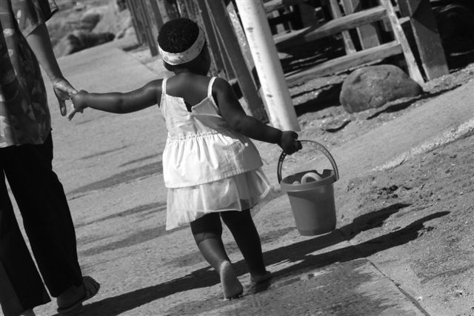

3.2. Daily programme/daily routines, including design of activities, routines and transitions
Daily programme

The programmes below are suggestions and ECD centres may differ in their implementation of activity schedules. It is vitally important to cater to the needs of the various age groups taking into account their particular developmental needs and abilities.

Typical programme for babies
07.00 – 08.30 | Arrival, talk to parents, breakfast
08.30 – 09.30 | Individual activities , pampering
09.30 – 10.00 | Nappies and feeding
10.00 – 11.00 | Individual time – outdoors if possible
11.00 – 12.00 | Nappies, lunch
12.00 – 14.00 | Nap, individual time with those who are awake
14.00 – 14.30 | Nappies, feeding
14.30 – 16.30 | Individual activities , pampering
16.30 – 17.30 | Nappies, get ready for home time, pack bags, complete message books

Note:
- Babies need individual attention and lots of pampering
- Plans run according to individual routine needs such as sleeping, eating, nappy changes
- Individual attention can be in the form of singing, toys, games, cuddles, stories, crawling, massages

Typical programme for toddlers
07.00 – 08.00 | Arrival, talk to parents, breakfast, change nappies/toilet training
08.30 – 09.30 | Free play – blocks, toys, books, creative activities
09.00 – 09.30 | Nappies/toilet training and snack
09.30 – 09.50 | Music and movement activities
09.50 –11.30 | Outdoor play and/or nap
11.30 – 12.00 | Nappies/toilet training, wash hands
12.00 – 12.30 | Lunch
12.30 – 12.45 | Story
12.45 – 14.00 | Outdoor play or indoor free play and/or nap
14.00 – 14.30 | Nappies/toilet training
14.30 –15.00 | Individual language/play activities
15.00 – 15.30 | Wash routine and snack
15.30 – 16.30 | Indoor free play or outdoor play
16.30 –17.30 | Nappies/toilet training, get ready for home time, pack bags, complete message books

Note:
- Toddlers need a variety of play experiences
- They need lots of language input in the form of rhymes, songs and stories
- Remember they may still have individual sleep needs/times
- Still need individual attention as they are still at parallel play stage

Typical programme for young children
07.00-07.30 | Arrival and free play
07.30-08.00 | Breakfast
08.00-08.20 | Morning ring
08.20-09.30 | Creative activities, educational games
09.30-09.50 | Music or movement
09.50-10.10 | Toilet and wash hands
10.10 – 10.30 | Snack
10.30 -11.45 | Outdoor play
11.45- 12.00 | Toilet and wash hands
12.00 -12.30 | Lunch
12.50 -14.15 | Rest or nap time
14.15-14.30 | Toilet and wash hands
14.30-16.00 | Outdoor play
16.00-17.30 | Indoor free play , prepare for home, pack bags
Note:
- Young children need lots of variety and time for individual as well as group activities
Weekly programme

In addition to daily programmes, we need to consider weekly as well as longer term planning.

Often ECD centres will have a weekly routine that may allow for particular activities on certain days e.g. ‘make and bake’ on a Friday. They may also need to accommodate extramural activities that often take place in the afternoons when the schedule is more relaxed. Themes will often slot into these weekly schedules too.


Themes help us to focus our learning objectives and encourage integrated learning. They also create a shared context for further meaningful interactions between practitioner and child, and between the children themselves. Choosing exciting themes and including new information stimulates the child’s curiosity about the world around them, helps them make sense of what they already know and encourages active learning.
Activities in the playroom are usually linked to your selected theme. This includes outings or demonstrations and talks from outside visitors. For example, if your theme is the sea, you may read stories like Eric the Hermit Crab or The Sailor Dog. You may set up creative art activities like making shell collages or sand paintings. You may use movement activities that require children to ‘act’ what it feels like to be a crab, dolphin, or shark. In other words, you provide opportunities for children to explore the theme experientially in many different ways.

key concept
Some ideas for themes can include:
- Community helpers and careers
- Fairy tales and legends
- Health and nutrition
- Holidays
- Outer space

Completing an activity plan

Activity plan – Sample

Name of activity Butterfly Pictures

Time needed 45 minutes

Age of children 3.5–5 yrs

Theme Insects

Resources needed

Thin cardboard cut in the shape of a butterfly and folded in the middle
Red, blue, yellow, black and white paint with droppers
Thin paintbrushes
Aprons for the children

Learning environment management
Indoor activity
This activity is for four children to do at one table. No chairs – standing activity
Children will take turns as they will be busy with sub-activities and free play in the learning areas.

Preparation
Cut out butterfly shapes – 1 per child – fold in half
Mix paint
Lay out one butterfly per learner on a table. Put the rest of butterflies in a tin in the middle of the table
Place two sets of paint and droppers between two spaces

Ideas for extension activities

Provide thin brushes so children can to add detail to their butterflies

Self-evaluation, feedback and how to improve the activity
Generally went well, but some children struggled with the idea of only putting paint on one side of the butterfly.
Blue paint was too thick and a bit lumpy, which made it hard to use in the droppers.
Need to provide crayons for Alice, Themba and Mandy to write their own names.
Enough time allocated – goes quite quickly.
Children really enjoyed the activity as they liked the colourful butterflies produced. Most could identify the secondary colours created – Jonah needs help there.
Quite a few children used the extension – particularly in adding a black body in the middle of the butterfly. Could stimulate more interest by showing pictures of detail on butterfly wings.

Activity plan – Main activity (sample)
Learning outcomes | Description of activities
Introduction
Cognitive – Numeracy – numbers in the fingerplay – use correct number of fingers  Awareness of caterpillars and butterflies – life cycle concept  Language – saying the fingerplay  Fine motor – manipulating their fingers in the fingerplay | Fingerplay of “5 wriggly caterpillars”  Remind the children to wear aprons.
Body
Fine motor coordination – using droppers for paint, folding the butterfly and rubbing it to create mirror image  Gross motor – standing activity – stretching for paint – spatial awareness (put paint on one side only)  Social – encouraged to discuss what they are doing, share sets of paint, may have to wait turn for a specific colour  Cognitive – Colour awareness and mixing of colours | Butterfly shaped cardboard for each child  Encourage children to use droppers from the paint pots to place dots of paint on one side of the butterfly only  Once complete, they fold the butterfly again so that colours mix and are transferred to the other side too to create a mirror image
Conclusion
Language – vocabulary extension – dark green, bright orange etc. | Discuss different colours that can be seen i.e. secondary colours like orange that were made from red and yellow when putting them on the rack to dry.

When you complete your activity plan with as much detail as possible, you create a record that you can file and keep for future reference. Next time you do the activity or when another ECD practitioner uses your idea, it is clear what needs to be prepared for the activity, which skills are being encouraged and exactly how to manage the activity. You will also know what improvements can be made to ensure that the activity is most effective. It may seem like a lot of administration work but remember that you only need to write an activity plan once, as you can use it many times in your career as an ECD practitioner.

Make a file – organised into activity types – in which to keep your activity plans. In this way, when you need a learning activity, you can look through the activity plans in your file and choose one. You can also file activity plans you have borrowed from other ECD practitioners. In this way, your file will keep growing and become a valuable resource for you.

Activity plan template
Activity plan

Name of activity

Time needed

Age of children

Theme

Resources needed

Learning environment management

Preparation

Ideas for extension activities

Self-evaluation, feedback and how to improve the activity

Activity plan – continued
Learning outcomes | Description of activities
Introduction
Body | Main activity; sub-activities (if appropriate)
Conclusion

The two most important group language learning activities are morning or greeting ring and story time. While they are ECD practitioner directed, children need opportunities to add their input and be actively involved. If they are expected to just sit and listen, their concentration wanes and they begin to lose interest and fidget.

Morning ring
The morning ring is sometimes called a greeting ring because it is the first formal part of a daily programme when the whole group greets each other and their ECD practitioner. It is a good way to start the day as it is familiar and provides security for the children.

The morning ring is a time for discussion and allows the children to interact with you and each other in a group setting. They learn pro-social behaviour such as turn taking and listening to other ideas. It also assists them in developing self-confidence and overcoming any fears about speaking in front of a group.

There is no absolute set format for a morning ring – activities will depend on the day and programme. It can include:

- Singing a greeting song
- Taking the register and noting absentees or the number of children in ECD centre. This is a great counting opportunity
- A discussion on the weather and recording it on a weather chart
- Show-and-tell sessions about any items brought to the ECD centre that are usually theme related e.g. what red item has been brought to add to the theme table
- A discussion about the weekly theme or subtopics e.g. theme is transport, each day a different type is discussed such as land, air, sea, space
- A discussion of any news such as a birthdays, activities children were engaged in over a weekend, a new pet or an upcoming holiday or festival such as Easter, Eid or Passover
- Discussions on topical events that affect the children such as floods or major sports events
- Discussions on the daily programme and what the children can expect to do that day
- it is also a time for children to share about emotional issues that are worrying them or things they may be sad, happy or excited about
- Reminders on who are helpers for the day

Morning ring is not a passive time for the children even though they are sitting. They need to be actively drawn into the language activities so that their vocabulary can be extended, their curiosity can be stimulated and their attention held. It should also be a time where their cognitive skills are extended by learning new concepts.

The input from the children will take the form of contributions to the discussions or questions they want to ask. Show and tell activities are great opportunities for children to input about themselves and their interests. You should never force children to contribute. You can encourage them to answer questions but will need to be sensitive to non-verbal clues and not push a child if they are reluctant. Forcing them to participate can be harmful to their self-esteem and may cause them to withdraw further.

Discussions need to be well managed by the ECD practitioner to prevent some children from taking over. All children should feel that they have had a chance to speak. Clear rules will need to be established and gently enforced:

- Children should take turns in talking and not interrupt others
- Children should indicate if they have a contribution by putting up their hand. This takes lots of practise and even young children find it difficult not to blurt out answers in their excitement to be part of the discussions. You will need to be patient and not reprimand children harshly.
- Children should wait for the ECD practitioner to indicate they can speak

In this way, children learn to accept authority and respect others – vital skills that are needed in all social situations.

Children can be encouraged to be independent by sticking their names on a register chart as they arrive. Toddlers and younger children will need pictures or symbols next to their name, as they will not be able to recognise them yet. These symbols and pictures will need to be chosen carefully so there that they are bias free. During ring time, the chart can be reviewed and absentees easily identified.

Storytelling
Stories are not just a form of entertainment and relaxation but have many developmental outcomes.

Value of stories
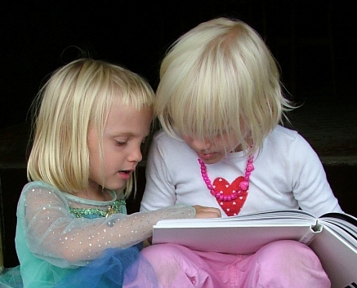
Language development takes place in the following ways:

- Children begin to understand and use the correct syntax (grammatical rules)
- They expand their vocabulary
- They become skilled listeners
- Learn to communicate ideas more effectively
- Begin to understand the creative use of language e.g. a play on words

Cognitive development is enhanced as children:

- Acquire new concepts and refine old ideas
- Learn to think in different ways as they are exposed to characters and their thoughts
- Learn to reason and follow logic
- Develop critical thinking skills
- Engage in problem solving

Personality development takes place when:

- They are given examples of appropriate choices made by characters in stories
- Recognise that everyone has value
- Learn to express themselves in socially accepted ways

Social and moral development is encouraged by characters who:

- Display pro-social behaviour
- Accept diversity
- Work well in groups
- Make ethical decisions

Aesthetics and creativity are encouraged by:

- Exposure to different artworks that are used to illustrate stories
- Sensory awareness
- Imaginative stories

QUOTE
Story-telling – getting to the heart of things
“… [S]tories enter my children and expand them, opening up spaces in which their imaginations can explore, fly and grow, where they can lose themselves and try out new truths. For children, we know that stories are effective ECD practitioners, seeping under the often locked door that is their resistance to instruction and moving inside them, becoming their own experience, their own lesson to resolve. It is a way children have learnt through the ages, though sadly today it is far less valued.”
– Doug Reeler

Make sure the story is developmentally appropriate

Children are encouraged to read and engage with books when you as the ECD practitioner model this behaviour. I am sure that if you think back to your childhood, you will remember the pleasure of being read to by your parents at bedtime or by an ECD practitioner. Stories are a means of escape and allow children to use their imagination.
We need to choose books wisely so that we can engage with the child at their developmental level. Characters in books should be believable and the children should be able to identify with their problems as well as the context of the story.

When you choose stories think of the group, their families, cultures, experiences, heritage and futures. It is said that we need to give children “roots and wings”. Roots are representative of security and a firm belief in themselves, and wings are the opportunities that lie ahead in their dreams.

Recommendations for suitable stories | Length of story time
Children of 2–3 years enjoy:  - simple concepts (letters, numbers, shapes, colours)  - simple stories with lots of repetition  - stories about children whose lives are similar to theirs  - stories they can identify with (e.g. getting a new baby sister or having a birthday party)  - pictures that help them to predict what will happen next in the story  - happy endings | 8–10 minutes
Recommendations for suitable stories | Length of story time
Children of 4 years enjoy:  - funny or exaggerated stories  - rhythmic and sing-song language that invites them to join in  - animals or young children as main characters  - stories which relate to their lives but which include some fantasy or unfamiliar elements  - clear, colourful illustrations or photos | 10–15 minutes
Children of 5–6 years enjoy:  - new facts, information and characters  - plots they can relate to (friendship, going to an ECD centre, family issues)  - language that has natural rhyme and repetition  - plots that encourage them to ask questions and learn more about the world around them  - illustrations that capture their interest and imagination  - fantasy stories – as long as they are not frightening | 15–20 minutes
Recommended stories for various age groups

Babies and young toddlers are not able to focus in group situations and thus reading stories to them individually is of greater importance as they still need to be exposed to books. Babies will enjoy board books with bold pictures and one or two words per page. The content will revolve around them, their toys, their clothes, their bottles etc and their routines. Toddlers also need simple hardwearing books as they want to be independent and page through books themselves. They can cope with simple stories that revolve around their routines and the context of their immediate environment such as family members and pets.

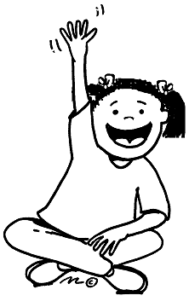
Storytelling in a group context

Storytelling is a vitally important skill to learn as an ECD practitioner. While reading stories, we are often focused on the book and cannot engage with the children in the group as much. This makes it more difficult to control the group and also to see how children are reacting to the story. When telling a story, we can look around and focus on individual children more easily.

Another advantage is that we can use props or illustrations more easily and children do not have to wait to ‘see the pictures’. This is especially important when working with large groups. Reading of stories is more suited to small groups or with individual children in the book area.

When telling stories you need to be on the same level as the children so that they are not craning their necks to see you or the illustrations. They need to be as close as possible but each child in the group needs to be able to see you clearly. Where possible it is best to sit in a semi-circle but this may be difficult in large groups where space is limited.

It takes practise but you will soon develop the skills needed. Try to be as natural as possible in your tone of speech and also vary the loudness of your voice. Children will listen closely if you suddenly whisper and use different voices to represent different characters. Your enthusiasm and enjoyment of a story will positively affect the children.

While we want to involve children, avoid constantly pausing the story to ask children questions like “What colour was her dress?” Stories are to be enjoyed and should not become verbal comprehension tests. You can ask questions like “What do you think will happen next?” but again this should not interrupt the flow of the story.

Illustrations and props are an excellent way of maintaining focus and attention – especially for distractible children. They also:

- Stimulate children’s imagination
- Introduce children to appreciating creative art made by others
- Invite children to relate to characters and understand the characters’ emotions
- Help the children to develop empathy for particular characters
- Provide children with key early literacy skills such as following a developing narrative
- Help children to make sense of what they are hearing
- Introduce children to other worlds and make the unfamiliar familiar
- Encourage children to think about what the next step in the story will be: what they think is going to happen, what they hope will happen – all important examples of creative thinking
You do not only need to use pictures with stories. You can also use

- Puppets
- Flannel boards
- Surprise objects
- A TV box
- Flash cards
- Three-dimensional objects
- Brightly coloured posters and pictures
- Story tapes or CDs
- Story apron and finger puppets

You can include sensory experiences like tasting, smelling, hearing and touching to enhance understanding. If you were telling a story about bees, you could use a silk flower with ‘pollen’ to pass around for the children to look at and smell. (The pollen could be sweet smelling talcum powder). The children could also be asked to close their eyes and open their mouths at the end of the story so that each could get a drop of honey to taste on their tongue.

Be careful though, of using too many props in one story as you will spend your time sorting them out and the emphasis will be taken away from the story too. The children will focus only on the props and not on the content.

Pictures and illustrations like flannelboard pictures or puppets are fantastic resources too if used wisely. Pictures should be brightly coloured and clear without too much detail so that all can see them. Only illustrate the most important parts of the story or characters and make sure that pictures are all in scale (i.e. the child should not be bigger than the parent etc). Organise the pictures well so that they are in order and you don’t distract the children by fiddling around looking for the next one.

Children’s stories

As adults we forget that children may have ideas for stories of their own. From four years on, most children are ready to engage in telling their own stories and their self-esteem is raised when adults actually listen and value them

Children can cooperate in telling stories in a group. The ECD practitioner begins with “once upon a time in” and the first child adds on. Each child in the group is then given an opportunity to add on another piece of the story. Value can be added by writing down the story and putting it in the book corner. In this way children feel very important and the link between spoken and written language is established. It also encourages children to listen to and respect each other and stimulates their imaginations.

Children really enjoy telling their own stories. This is a very important way to nurture children's love for books, reading and stories and make the connection with literacy skills. These stories can be written down verbatim in special books (cheap blank paged exercise books are ideal) and the child can then draw pictures to illustrate the story. Then you can read the story back to the child who told it. You can do this on a one-on-one basis, or you can read the story to the group. The proud smile on the child 'writer's' face will prove to you just what a confidence-boosting and affirming storytelling activity this is.
Children also love to ‘read’ familiar stories or retell them. You can encourage this by spending time in the book area or letting them ‘read’ to one another.

QUOTE
“The worth of a book is to be measured by what you can carry away from it.”
– James Bryce

Using books to enhance skills

Various cognitive skills such as prediction, early numeracy and problem solving can be enhanced with stories.


- You can make use of prediction by asking: “What do you think will happen next?” or “How do you think the little girl feels about losing her toy?”
- You can foster numeracy skills with questions such as, “How many cakes were left for Monkey?” There are also books based on numbers like The Very Hungry Caterpillar by Eric Carle, which also reinforces the days of the week.
- Problem solving can be practised by posing questions related to a story, for instance, “What would you do if you climbed a tree and could not get down?” Children then have an opportunity to think for themselves and answers are not right or wrong.

Well chosen books and stories will also explain issues, experiences or difficult emotions that children may encounter in a way that is easier for them to understand and deal with, as they may identify with the characters.

You should now be able to look at books more critically and with a new understanding. You should be able to choose stories more wisely so that the children in your care not only enjoy them but also interact with them more meaningfully.

Picasso said that, “Every child is born an artist. The trick is to remain an artist.”

As ECD practitioners, you can facilitate this process by allowing children to express themselves freely through art activities. Too often the importance of creativity is forgotten and art activities are reduced to worksheets, colouring in or collages that looks exactly the same because the children have been told what to stick where.

Value of art activities
The contribution of art to the holistic development of children cannot be underestimated. While people often only think of it as being focussed on fine motor development, it covers the whole spectrum of emotional, cognitive, social and language development as well if designed well.

When children... | They learn...
smear a page with brightly coloured finger paint | - about touch, colour, texture  - how to use their hands  - about cause and effect
cut with scissors | - to control of the small muscles in their hand (fine motor skills)  - hand-eye coordination
cut paper and stick it on the page in their own pattern | - to be in charge of themselves  - to have a plan and carry it out  - fine motor skills  - to develop hand-eye coordination  - to share scissors and glue (if they are sharing)
go for a nature walk and make an autumn collage of leaves | - to understand the world around them intellectually  - to build their bodies and lungs  - to carry out steps in a process  - to select and choose (the leaves that they want), decision-making
Table 3.2 What children can learn from art activities

In terms of emotional development, art activities allow children to express their feelings, ideas and concerns in a non-verbal way. Toddlers and young children do not always have the vocabulary to express themselves through language – particularly with abstract ideas like emotions. Art gives them a means of releasing these feelings and becomes a form of therapy for them to express concerns or issues that they have little control over.

Art also allows children the freedom to use their initiative and make their own choices, which builds their independence and self-esteem. They get a sense of accomplishment and experience success.

By talking to children about their art, we can increase their vocabulary and language skills as we give them the words for emotions and feelings.

Drawings and paintings are also a means of symbolic representation and is the start of pre-literacy development. Letters are really shapes that are given meaning.

This shift towards the symbolic level is a sign that children are cognitively developing and moving from the sensory-motor phase into the pre-operational stage (Piaget’s theory). They use their thinking skills by observing, solving problems, making decisions, testing ideas, sorting items etc.

Their social skills are honed by cooperating with others at the activities, waiting their turn for a space or a pair of scissors. They may talk to each other about their artwork in so doing express ideas and share their thoughts.

Fine motor development is facilitated as they strengthen their finger muscles and thus develop control over tools like paintbrushes. This is important for the development of writing skills. Working with dough and clay, cutting with scissors and using implements are also assisting in their fine motor functions.


Setting up art activities
It will depend on the playschool and space available but we usually plan for one main art activity and two sub activities. In this way, at least twelve children can be busy with art so that the session does not take too long. It also allows for children to engage in a variety of activities and develop different skills e.g. painting, dough and collage. Your attention will be focused on the main activity so the two sub activities should be more self-help orientated like playdough.

When designing your art activities for the day or week, it is important to bear in mind:

- Age: consider the ages of the children and the age appropriate skills that you should be developing – expecting toddlers to cut with scissors is unrealistic. If the activities are too easy, the children will do them very quickly and may use the materials inappropriately. If the activities are too difficult, the children will become frustrated and may not complete them. They will experience a sense of failure, which may prevent them from trying other activities.
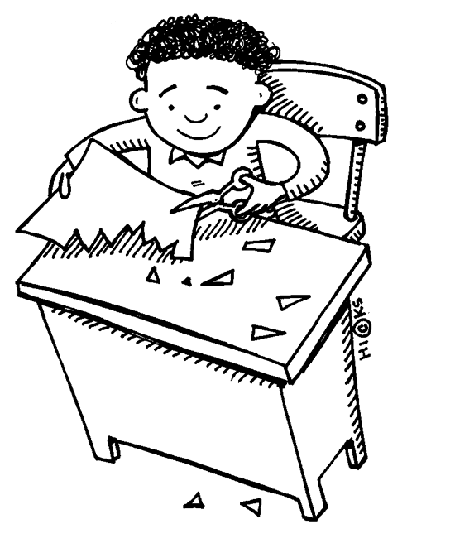
- Equipment: do you have all the equipment that is needed? It is very frustrating for children to do a collage where there are only a few items for them to use or there is too little red paint to finish their picture.
- Space: what space is needed and at what level? Box construction needs a lot of space and is best done on the floor; painting at easels may use less space than if it is done at a table. Dough is best done at a table and is not ideal on the floor. Remember that art can be done outside if there is a veranda or an area that is level and not in the hot sun. It is best if the area is close to water to facilitate cleaning up.
- Assistance: how complicated is the activity or can they manage on their own? Remember not to set up three activities that all require a high degree of supervision. You will struggle to give all the attention needed and the children will become frustrated.
- Theme: art is an excellent way of reinforcing concepts from the theme but not all activities will allow for this. Try to make the main activity theme based at least.
- Health and safety: paints and dyes should not be toxic and scissors should be blunt nosed. You may also need to cut the points off toothpicks if used with toddlers or ensure that paintbrush handles are no long enough to poke them in the eye as they paint.
- Differentiation: activities are set up to cater for all the children in the ECD centre – those with well-developed skills and those who may be struggling. Thus when setting out a painting activity, you could have brushes of different thicknesses so that children with good pencil grip can choose to use thinner brushes. You may also have different sizes of paper – children who feel confident of their abilities may choose smaller pieces as they can control their brushes better while others may want larger pieces. Differentiation allows children to succeed at the task no matter their skill level.

Ideas for various art activities
The following ideas are by no means comprehensive and do not cover all the possibilities for art activities. You can use them to stimulate your ideas and you can do research on the internet or in books to get more ideas.

Drawing

- Use paper of different colours, shapes, sizes and textures
- Drawing tools:
  - Crayons of different thicknesses and shapes (triangular and animal shaped available locally)
  - Kokis of different thicknesses
  - Thick pencils – 2B preferable
  - Ballpoint pens
  - Chalk – dry and wet (dip in sugar water)
  - Podgy pastels
  - Thick pieces of charcoal
  - Sticks or fingers in damp sand
- “Trace a child” – lie on a large sheet of paper, draw around them and then they can draw in their features and clothes
- Use carbon paper to make ‘magic’ copies
- Work at an easel or stick paper on the wall for a mural

Painting

- Finger-paint – can be bought or made
- Different size brushes – the younger the child, the thicker the brush
- Add glitter, sand, salt etc for texture
- Roller paint in deodorant bottles – will need to make paint from a thin starch mixture
- Murals or at easels
- Powder paint and water – give the children dry paint to mix on their own (suitable for four and older)
- Different paper in terms of colour, size, shape – also strong wet paper as it gives a watercolour effect.
- Draw with crayon and paint over dye – very effective with white crayon
- Paint their items from box construction
- Use feathers as brushes. Seagull feathers best but you will need disinfected them against lice.
- Use sponges or pegs with sponge pieces clamped in them
- Marble rolling – place marbles in paint and paper in a photostat box lid. Take marbles out of the paint with teaspoons and roll around on the paper in the box. This is not suitable for toddlers or three-year-olds as they tend to throw the marbles around and do not have the control to roll the marbles gently.
- String – use thick string or pieces of rope.
- Blow painting – younger children will suck the paint up in the straw so it is best to put the paint on the page and then blow it around with a straw.

- Splatter painting – use old toothbrushes and run the thumb over them to create splatter effect on the page. You can also stencils to create fun pictures.
- Paint outside equipment with water and large paint brushes
- Bubble painting – mix up paint or dye with dishwashing liquid in a small bowl. Children use straws to blow bubbles and then place paper over the bowl to ‘print’ the bubble pattern. Younger children will suck up the bubbles so rather only attempt this activity with children of four years and older.

Collage

For collage or sticking activities to be really effective, the paper or cardboard that is used as the base must be strong enough to hold the items e.g. paper on paper works, bottle tops, buttons etc should be stuck onto thick cardboard.

It is advisable to have a sorting tray to hold the various items that are available for sticking. This teaches children to organise and sort items and makes it easier to see what they want. A sorting tray can be made by putting smaller boxes into a shoebox. You can also use different bowls.

Young children find it difficult to work with glue sticks and it is often not strong enough. White wood glue is the best option. It can be applied with special applicators or glue brushes that are available at most art shops. You can also use sucker sticks or old paintbrushes with the bristles cut shorter.

A good way of extending these activities is to add drawing items and scissors so that children can combine their art media and also customise the materials set out e.g. pieces of wool can be cut into shorter pieces.

- Nature items such as seeds, leaves, dried petals, sticks etc. It is advisable not to mix natural and manufactured or synthetic items
- Paper tearing – tear pieces of colourful paper or from magazines and stick them into a shape or basic picture to form a mosaic effect
- String of different thicknesses, colours and lengths
- Stick to a theme e.g. red (wool, buttons, paper) or shells (different sizes and shapes)
- Masks, bangles, hats, crowns, chains and pendants can be made by sticking items to cardboard
- Cut out paper in shape e.g. fish, shell, shape and stick items or paper onto it
- You will need to collect items to stick. Here is a basic list: beads, coloured paper, cards, buttons, packaging materials (poly chips), confetti, bottle tops, cotton wool, egg shells, material, feathers, tea leaves, sweet papers, sand paper, sawdust, sequins, shells, foil, straws, wool, wood shavings, leather pieces etc.

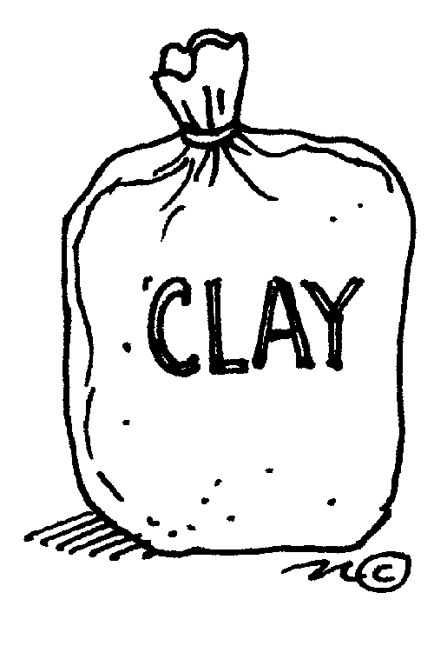
Modelling

- You can use clay to make coil pots, thumb pots and candleholders. It is a natural substance and is therefore used with natural substances like seeds, sticks, leaves, herbs, shells, dried flowers etc. Wooden implements work best and are available very cheaply at craft shops. Alternately, wooden sucker sticks are a free resource. Older children can be encouraged to shape animals e.g. snail, snake, porcupine (toothpick holder), dog etc. Clay is more difficult to use, as it requires more strength in the fingers than playdough. Remember to keep the packet well sealed or it dries out. Clay items can be dried in the sun but they are brittle and prone to breakage.
- Play dough can easily be made, as the bought version is very expensive. You can make it in different colours with different smells to stimulate sensory perceptions. Beware though, toddlers like to eat it. You can discourage this by making it with large amounts of salt. The salt also helps to preserve it and prevent mould. Keep the play dough in an airtight container or it will go hard. Do not leave unused, as it can go mouldy. You can use plastic cutters and knives as well as cookie syringes. Children enjoy it when it is set out in a colour theme or extensions, such as when baking trays are provided. Older children can mix the colours and see what new colours are made.

Construction activities

When setting out construction activities, remember to provide plenty of space; these activities are best done on a plastic mat on the floor. The children should be provided with basics to build (large items such as boxes, polystyrene pieces, and wood) and also sorting trays of smaller items for ‘decoration’.

Wood glue should be provided as it is strong enough to stick the larger items but packaging tape can also be used as an extra resource. Once the items are completed, they can be painted. Children can make binoculars, computers etc – they are only limited by their imagination and the availability of junk!

- Polystyrene constructions using polystyrene pieces, wood glue and items such as plastic tops, wool, pieces of netting etc.
- Box constructions using a variety of large and smaller boxes and cylinders from toilet rolls etc with corks, string etc.

You can collect lots of ‘junk’ to use such as:
egg boxes, wood, cotton reels, boxes, tubes, polystyrene, film containers, bottle caps, matchboxes, bits of fabric, toilet roll tubes, string, shoeboxes, bottle tops, straws – in fact almost anything made of paper, cardboard, plastic or fabric. Never use any glass items, as they are potentially very dangerous.

Weaving

Weaving is best suited to children from four years on, as it requires a higher level of fine motor coordination as well as spatial awareness of over and under.

- Paper strips can be woven through a ‘frame”. You can create the frame by cutting slits in a sheet of paper. Ensure that the ends remain solid. (almost like cutting slits when making paper lanterns)
- Strips of fabric through netting – orange bags are a good resource to use.

Printing

- Commercially available stamps
- Create your own stamps by sticking foam shapes etc onto wood blocks
- You can use paint or dye as the ‘ink’. It is easiest to use if it is poured into a polystyrene tray with a thin piece of sponge to act as the inkpad.

This is an excellent way to introduce children to nutrition. They are able to taste, smell, feel and work with real food. You can guide them in making healthy choices in terms of what they eat and introduce them to new and different foods.

There are many benefits besides this as it relates directly to many developmental areas. It is a favourite activity of children as they enjoy the independence and the reward of eating their efforts.

These activities relate directly to life experiences and develop self-help skills. Children should assist in clearing away and leaving their workstation neat for the next person. This also teaches them to respect others.

Some hints and tips
- Try to alternate sweet and savoury treats in order to avoid encouraging children to eat only sweet things. You might be limited to items that do not need cooking if there is no stove or oven at your ECD centre.
- Get recipes from parents of different cultures or religious groups and coincide them with festivals e.g. Easter or Pesach
- Use seasonal fruit and vegetables as they are cheaper
- Try to make mostly individual recipes. Occasionally young children will enjoy a group effort such as taking turns to stir ingredients for a large cake
- Be mindful of children with allergies or religious dietary needs in your ECD centre. Try to find alternatives that they can enjoy as well so they do not feel excluded.
- You will need some basic equipment e.g. bowls, spoons, knives etc. Always use plastic to avoid any accidents. Plastic knives cut adequately.
- Make your activity look appealing by using coloured coded bowls cloth etc.

- Do not put out the ingredients before you start as children cannot resist picking at food and you might not have enough for all the children by the time you get to the activity
- Work with a maximum of four children at a time as they often need a lot of help. Arrange your other art activities wisely, so that the rest of the ECD centre can play independently or be involved in activities like blocks or fantasy play that are set out.
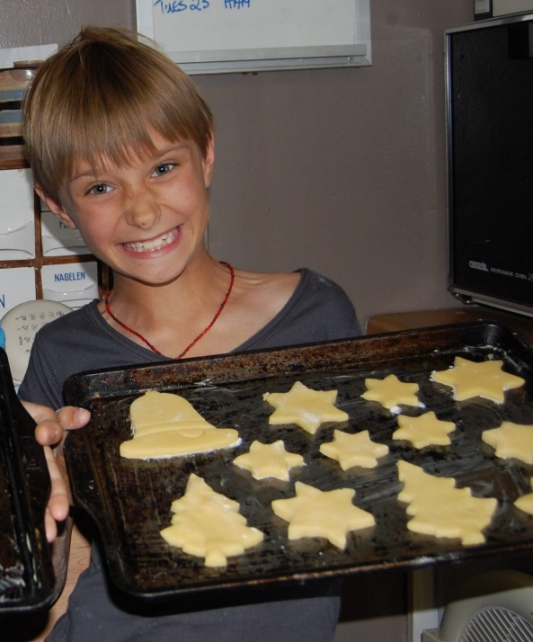
- Make name labels in advance, so that children can identify their cookie or item once they have made it. This is best done on cardboard. Do not make them too big or they might burn on the grill in the oven if used on cooked foods.
- Ensure that children wash their hands properly before and after this activity
- Do not use Aromat but try to use natural seasonings like salt and pepper. You should season the food lightly as children are sensitive to strong tastes and they will be heavy handed with spices if given free reign.
- While babies are not able to participate in these types of activities, the simplest recipes can be used with toddlers provided they do not use any knives (even plastic ones). They can decorate iced biscuits, dip marshmallows in chocolate and put pieces of polony etc on mini-pizzas.
- Safety and supervision is of utmost importance as children can very easily burn themselves with hot water or cut themselves (even with plastic knives).

Recipe Charts
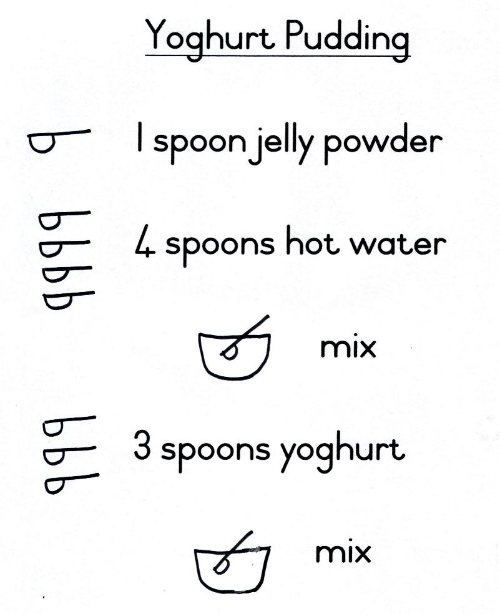
Recipe charts are a very easy way of encouraging emergent literacy and numeracy skills with young children. They need to be pictorial and numeric (as in the example) so that the children can follow them easily. Remember to cover them with plastic, as the children will touch them in order to ‘read’ the recipe. The recipe can form the basis of a morning ring so that you can prepare the children and they can start memorising the steps. It also creates excitement and enthusiasm. You could show the children the ingredients and let them guess or predict what they are going to make. In this way, you encourage participation and develop cognitive skills.

They need to be big enough to read clearly, so an A3 page is ideal. The lettering should be clear and follow the rounded ECD script as per the example. Avoid putting too much on the page as this makes it more difficult for the children to read. You can cut out pictures from magazines of the ingredients or the packaging to add to the charts.

Some suitable individual recipes
Sweets

Chocolate marshmallows  1 marshmallow  melted chocolate  coconut  toothpick | Method:  I. Place the marshmallow on the end of the toothpick.  2. Dip in melted chocolate  3. Roll in coconut and allow to harden.  The chocolate can be melted in a double-boiler by the ECD practitioner as an introductory activity
Crispy crackolates  1 tsp rice crispies  1 tsp condensed milk  1 tsp cocoa  1 cookie cup | Method:  - Mix all ingredients together.  - Place in cookie cup and allow to harden.  To make mixing easier and to make the condensed milk last longer, you can dilute the condensed milk with a small amount of milk.
Peanut butter balls  2 tsp peanut butter  2.5 tsp castor sugar  3 tsp milk powder  2 tsp syrup | Method:  - Mix all ingredients together.  - Roll into balls.  - Decorate as desired.

Puddings

Fruit salad  ¼ orange  ¼ banana  ¼ apple  3 grapes  I tsp orange juice | Method:  - Cut up fruit.  - Add orange juice.  - Chill.
Fruit jelly  4 tsp jelly powder  6 tsp boiling water  6 tsp cold water  1 tsp fruit | Method:  1.Make up jelly  2.Place in foil cookie cup with cut up fruit  3. Chill.
Parfaits  2 finger biscuits  5 banana pieces  2 tsp custard  1 tsp jelly | Method:  1. Place biscuits in bowl.  2. Layer other ingredients over the biscuits, starting and ending with custard.  3. Decorate with chocolate vermicelli or a flake.  You can make the jelly and custard beforehand.

Savouries

Movement rings or activities are an ideal opportunity to develop children’s gross motor skills and other concepts in a more planned and structured way so that developmental needs can be met. We know that children are active learners and need to move to learn, as there is a close relationship between physical and cognitive development. During movement activities, you can encourage the children to move with precision, teach new skills and encourage children to enjoy moving and using their bodies. These activities should be planned for at least twice a week.

Movement development
Gross and fine motor skills follow a predictable pattern and so certain skills and movements will only develop once a child is ready both physically and neurologically. There are established norms for gross motor development i.e. we can expect a baby of six months to start sitting unaided, but these are guidelines so children will show individual differences in their rates of development.

David Gallahue, Dean Emeritus of the Playschool of Health, Physical Education and Recreation at Indiana University Bloomington, studied the phenomenon of movement and wrote many books on the subject. His pyramid below also shows that children need to consolidate their skills at each stage in order to be able to move on and develop skills at the next level.

Specific sport skills e.g.
swimming strokes, striking etc.

Fundamental skills e.g.
catching, throwing, kicking etc.

Fundamental movement patterns e.g.
Running, sliding, leaping, galloping, skipping, marching etc.

Newborn reflexes e.g. gripping, blinking, sucking, rolling, sitting, crawling etc.

Figure 3.1 Gallahue’s pyramid
Categories of movement
Human movement can be categorised as stability, locomotion or manipulation.

- Stabilty is defined as the ability to maintain one’s balance in relationship to the force of gravity even when the body is in an unusual position. It is the most basic form of movement.
- Locomotion is defined as changes in location of the body relative to fixed points on the ground.
- Manipulation is the giving and receiving of force from objects using the hands and feet.

The examples in this table may help you to understand the concepts better. It is important that children develop all three categories of movement dependent on their age. For example:

- Babies will roll, crawl and learn to roll a ball
- Toddlers will also bend, stand, turn, walk and throw
- Young children will further develop skills and start dodging, leaping and catching

Stability | Locomotion | Manipulation
- bend  - stretch  - twist  - turn  - swing  - stand  - inverted supports  - rolling  - landing  - stopping  - dodging  - static postures  - sway | - walk  - crawl  - run  - jump  - hop  - skip  - slide  - leap  - climb  - gallop  - march | - throw  - catch  - kick  - trap  - strike  - volley  - bounce  - roll

Examples of stability, locomotion and manipulation

Movement rings
Movement rings are usually alternated with music rings but can take place at any stage in a programme. Some ECD centres prefer to start the day with these activities.

The activities need to be well planned so that

- The children’s needs and interests can be met
- There is variety and all skills can be adequately covered
- They can be linked to theme planning to expand concepts
- Children’s strengths can be used to develop their weaker areas
- Children can understand shared and own space
- Different levels of space are used i.e. lying on the floor, kneeling and standing
- There is progression according to developmental norms

You will need some equipment for movement rings. While you can buy items such as beanbags, you can also create your own learning resources by using scrap items and your creativity.
We have given examples of four different types of rings that can be used and alternated. They can be seen as the basics on which you can expand and build.

These activities are all designed for an ECD centre of four-year-olds and would last about fifteen minutes each.

3. Obstacle course

Introduction: Game of statues. Children move around and freeze when you blow the whistle.
Main part:
Mats to sit on and wait their turn
Table to climb over
Hoops to walk through
Ladder to crawl through
Balance beam
Sticks to jump over
Mat to log-roll over
Take beanbag and throw into basket from a hoop

4. Apparatus Stations

Introduction: Give out five of each coloured sticker (red, yellow, blue, green, orange), one to each child to wear
(group of 25)

Main part: five stations are set out apart from each other so there is enough space for each child to play. (Best done outside where possible)
Tennequoit rings
Hoola hoops
Bean bags
1

Large beach balls
Skipping ropes

Each colour group gets sent to a station. They play (with guidance from the ECD practitioner) for about four minutes before whistle blows and ECD practitioner directs them to the next activity.

Conclusion: Dismiss children according to colour or hair colour or short vs. long, or curly vs. straight, pigtails vs. plaits

Ring activities in this format are obviously not suitable for babies. Instead, they will need individual attention.

Simplified versions can be presented with small groups of toddlers but bear in mind that their attention span is very short and they will not be able to work well independently yet. Very basic obstacle courses and experimentation with equipment like beanbags may be possible. They will enjoy a story type ring as they can copy the ECD practitioner if the movements are simple and within their range.

At this age, they love repetition and this strategy can be used effectively to reinforce movements and practice their skills. They like carrying objects and packing in and out, so they could be engaged in fetching beanbags from one basket and carrying them to another.

Programme planning and evaluation
Long-term planning
Longer range planning is also important so that themes can run in a logical sequence and so you can take outings and major events into account. These can be used to a positive effect to change your ECD classroom and to provide activities that stimulate further interest and learning e.g. Arbour day – your theme would be around trees and growing and you would have access to posters in the newspaper.

Developmental outcomes
Suitably planned learning activities that support the developmental needs and abilities of the group will have a stronger chance of succeeding. This is because children will be working at a level that they can cope with and thus have confidence in themselves and will learn more readily.

You should cover all of the following areas on a daily or weekly basis to ensure that holistic development is taking place.

The main domains of development
You need to plan appropriately to ensure that you cover the complete spectrum within the developmental age and stage of the children in the group.

For instance:
- Most of the development needed during the baby stage is physical. You will need to provide opportunities to be on the floor so that they have a chance to roll and crawl. Babies that are held all day or left in a cot will not develop appropriate skills.
- Young children also need physical stimulation but this involves more challenging equipment such as obstacle courses, jungle gyms, music and movement sessions. If you do not expose a child to galloping in music, they will not easily learn the skill.

Activity purposes
The developmental outcomes can be further broken down into goals for each particular activity that you present or provide in the class.

Physical development includes fine motor, gross motor, balance and rhythm.
Cognitive development includes concept development, thinking, reasoning, problem solving, counting, and predicting as well as emergent literacy and numeracy skills.
Language development includes vocabulary building through listening and speaking and non-verbal language such as gestures.
Social and emotional development includes self-concept and identity, independence, affection, dealing with conflict, pro-social behaviour, accepting authority and empathy.
Creative and imaginative development includes imaginative play skills, expressing ideas, curiosity and a desire for knowledge.
Moral development includes values such as sharing, kindness, knowing right from wrong, acceptance of discipline and rules.

These goals are often integrated as they cannot be separated and are closely linked and related. One activity may cover many of the goals above – either by design or accidentally.
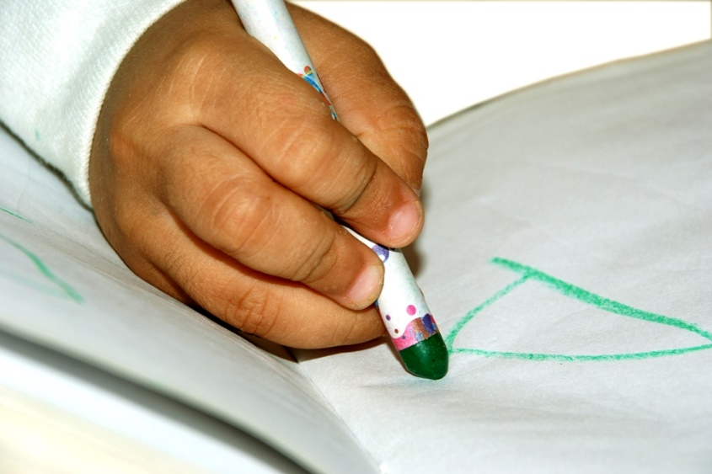
You may set up an art activity that focuses on drawing with crayons. This most obviously covers fine motor and creative skills. However, as the children are engaged in the activity:

- They discuss the colours they are using
- Take turns to use the favourite red crayon
- They talk about what they are drawing

The activity will thus cover cognitive, language, social and emotional as well as imaginative development.

Think about how an activity, such as drawing with crayons, can stimulate more than one area of development

- Using either the toddler programme or the programme for young children, explain the activity outcomes for:
- The greeting ring activity in the morning
- The free play activity in the morning
- The outside play activity in the afternoon
- Do you think this is a suitable daily programme for this age group? Would you make any changes? Explain your answer.
- The programme for young children includes a morning/greeting ring of twenty minutes. Explain what space you think you would need for this activity and any resources you would use for your class of 25 children.
- There are four children sitting at a table engaged in an art activity. The resources that have been provided are: blank paper, kokis of different thicknesses and colours, two pairs of scissors, glue sticks. They are happily chatting to one another and discussing the pictures they are drawing.
In the context of this scenario, identify and explain the following:
- Explain the purposes of the learning activity – what developmental outcomes are being met?
- Is this an integrated activity? Explain your answer.
- Explain when you would use the activity in the daily programme. Why would you choose that time?
- Approximately what age do you think these children are – think of the resources and setting. Give reasons for your answer.
- Is the activity appropriate? Explain your answer in terms of developmental norms.

3.4. Uses of information technology with children
As children use the computer and other forms of technology, they have the opportunity to meet the following technology standards. Established by the International Society for Technology in Education (ISTE), these standards are for children ages prekindergarten through second grade.
- Use input devices (e.g., mouse, keyboard, remote control) and output devices (e.g., monitor, printer) to successfully operate computers, VCRs, audiotapes, and other technologies.
- Use a variety of media and technology resources for directed and independent learning activities.
- Communicate about technology using developmentally appropriate and accurate terminology.
- Use developmentally appropriate multimedia resources (e.g., interactive books, educational software, elementary multimedia encyclopedias) to support learning.
- Work cooperatively and collaboratively with peers, family members, and others when using technology in the classroom.
- Demonstrate positive social and ethical behaviors when using technology.
- Practice responsible use of technology systems and software.
- Create developmentally appropriate multimedia products with support from teachers, family members, or student partners.
- Use technology resources (e.g., puzzles, logical thinking programs, writing tools, digital cameras, drawing tools) for problem solving, communication, and illustration of thoughts, ideas, and stories.
- Gather information and communicate with others using telecommunications, with support from teachers, family members, or student partners.

Cognitive Skills
As a tool, the computer has several advantages that can aid in children’s cognitive development.
- Computers are motivating for young children, increasing their time in on-task behavior. For example, one study found kindergarten children were on-task 90% of the time when they were on the computer.
- Computers provide consistent and frequent reinforcement.
- Computers allow children to work independently at their own pace.
- Software programs often provide extensive scaffolding of learning. Scaffolding is very important in developing cognitive skills.
- The computer provides unique opportunities that may enhance learning. For example, computers can allow children to access the “largest information bank—with the broadest range of quality and utility—the world has ever known”. With the computer, children can participate in simulations and manipulate variables that might not be possible in the real world.

FORMATIVE ASSESSMENT
• IAC0302 Describe the activities and components of a daily programme in own context
• IAC0304 Explain the use of Information Communication Technology (ICT) in early childhood development
(Weight 35%)

References

- Brűmmer, L. The Welcome Book 1998. ELRU:SA
- De Witt, MW and Booysen, MI. Focussing on the small child – insights from Psychology of Education. 1995. Acacia: Pretoria
- Downs, P (Aussie Sport). Willing and Able – an introduction to inclusive practices.1995.AussieAble- Australian Sports Commission
- Kapp, J A. Children with problems – an Orthopedagogical Perspective.1991.Van Schaik: Pretoria
- Department of Education (2001) Education White Paper 6 on Special Needs Education: Building an Inclusive Education and Training System. Pretoria.
- Department of Education (2008) National Strategy on Screening, Identification, Assessment and Support (SIAS school Pack)

Appendices
All qualifications and part qualifications registered on the National Qualifications Framework are public property. Thus the only payment that can be made for them is for service and reproduction. It is illegal to sell this material for profit. If the material is reproduced or quoted, the South African Qualifications Authority (SAQA) should be acknowledged as the source.

SOUTH AFRICAN QUALIFICATIONS AUTHORITY

REGISTERED QUALIFICATION:

Occupational Certificate: Early Childhood Development Practitioner

SAQA QUAL ID | QUALIFICATION TITLE
97542 | Occupational Certificate: Early Childhood Development Practitioner
ORIGINATOR
Development Quality Partner - ETDPSETA (Education)
PRIMARY OR DELEGATED QUALITY ASSURANCE FUNCTIONARY |  |  | NQF SUB-FRAMEWORK
- |  |  | OQSF - Occupational Qualifications Sub-framework
QUALIFICATION TYPE | FIELD |  | SUBFIELD
Occupational Certificate | Field 05 - Education, Training and Development |  | Early Childhood Development
ABET BAND | MINIMUM CREDITS | PRE-2009 NQF LEVEL | NQF LEVEL | QUAL CLASS
Undefined | 131 | Not Applicable | NQF Level 04 | Regular-ELOAC
REGISTRATION STATUS |  | SAQA DECISION NUMBER | REGISTRATION START DATE | REGISTRATION END DATE
Registered |  | IEXC 0002/16 | 2016-02-17 | 2019-02-17
LAST DATE FOR ENROLMENT |  | LAST DATE FOR ACHIEVEMENT
2020-02-17 |  | 2023-02-17

In all of the tables in this document, both the pre-2009 NQF Level and the NQF Level is shown. In the text (purpose statements, qualification rules, etc), any references to NQF Levels are to the pre-2009 levels unless specifically stated otherwise.

This qualification does not replace any other qualification and is not replaced by any other qualification.

PURPOSE AND RATIONALE OF THE QUALIFICATION

Purpose:
The purpose of this qualification is to prepare a learner to operate as an Early Childhood Development Practitioner.
An Early Childhood Development Practitioner plans and prepares early childhood activities, facilitates and mediates learning, observes and assesses the progress of children, and reflects on learning in an inclusive, play-based environment to support holistic development of children (from conception - school going) in different centre-based or non-centre based settings.
A qualified learner will be able to:
• Plan and prepare broad-phase learning environment and stimulating activities that meet the holistic needs of all children in centre-based or non-centre-based settings.
• Facilitate and mediate all aspects of the daily programme in a centre-based or non-centre based setting.
• Observe, assess and record each child's progress according to the age and stage.
• Compile a report of each child's progress.
• Maintain and promote the well-being, health, nutrition, safety and protection of children.
Rationale:
The Occupational Certificate: Early Childhood Development has been designed to meet the needs and interests of the early childhood development sector in a variety of settings and contexts with an inclusive focus on education, health and safety issues, amongst others. There is a vast need for early childhood development services and it is critical that the field must be served by competent practitioners. In order to meet the needs at early childhood development level, it is important to be able to identify and recognise competent early childhood development practitioners who are able to work in centre-based and non-centre-based early childhood development settings.
This qualification will provide a means to give recognition to practitioners at an entry level, thus making it possible for practitioners to increase their employment prospects within the Department of Basic Education. The Department of Social Development, through the registration of early childhood development centres and/or sites, may also provide business opportunities to successful practitioners who may wish to establish early childhood centres and/or sites. It will also provide access to a recognised career path and at the same time provide the field with suitably qualified professional practitioners.
The qualification will provide opportunities to people who wish to enter and/or continue learning in the early childhood development field, which include the employed, under-employed but not qualified, and school leavers. Every child has the right to high-quality, holistic education and care which forms the critical foundation for further development and learning from childhood into adulthood.
This necessitates the universal availability of high-quality early childhood development and education as a vital strategy to yield personal and long-term benefits to individual children, their families and the society at large.
Early childhood development is an essential component of economic development within the framework of child care services. Changing social and economic needs require parents to enter the labour market. Therefore quality early childhood development service provision is required to meet growing demands in the country, both in urban and rural settings.

LEARNING ASSUMED TO BE IN PLACE AND RECOGNITION OF PRIOR LEARNING

Recognition of Prior Learning (RPL):
RPL for access to the external integrated summative assessment: Accredited providers and approved workplaces must apply the internal assessment criteria specified in the related curriculum document to establish and confirm prior learning. Accredited providers and workplaces must confirm prior learning by issuing a Statement of Results or certifying a Work Experience Record.
RPL for access to the Qualification: Accredited providers and approved workplaces may recognise prior learning against the relevant access requirements.
Entry Requirements:
• National Certificate Vocational (NCV) at NQF Level 3.
Or
• Any other NQF Level 3 qualification.

RECOGNISE PREVIOUS LEARNING?

Y

QUALIFICATION RULES

This qualification is made up of the following compulsory Knowledge Modules, Practical Skill Modules and Work Experience Modules totalling 131 Credits:
Knowledge Modules: 43 Credits:
• 234201000-KM-01, Introduction to the early childhood development sector, at NQF Level 4, 4 Credits.
• 234201000-KM-02, Theories and Perspectives of Child Development, at NQF Level 5, 6 Credits.
• 234201000-KM-03, Planning and Programme Development in early childhood settings, at NQF Level 4, 8 Credits.
• 234201000-KM-04, Facilitation and mediation of active learning, at NQF Level 5, 12 Credits.
• 234201000-KM-05, Observation and assessment in early childhood development, at NQF Level 4, 4 Credits.
• 234201000-KM-06, Promotion of health, safety and well-being of children, at NQF Level 4, 6 Credits.
• 234201000-KM-07, Administration for early childhood development services and programmes, at NQF Level 3, 3 Credits.
Practical Skill Modules; 43 Credits:
• 234201000-PM-01, Plan and prepare inclusive educational activities and routines using an approved programme based on the curriculum framework, at NQF Level 4, 12 Credits.
• 234201000-PM-02, Facilitate and mediate active learning in an integrated and holistic learning programme, at NQF Level 5, 9 Credits.
• 234201000-PM-03, Observe, assess, record and report each child's progress according to the age and stage, at NQF Level 4, 4 Credits.
• 234201000-PM-04, Support and promote the health, nutrition, safety, protection and well-being of children, at NQF Level 4, 12 Credits.
• 234201000-PM-05, Build and maintain collaborative relationships with parents and other service providers, at NQF Level 4, 3 Credits.
• 234201000-PM-06, Prepare and maintain administrative systems, at NQF Level 3, 3 Credits.
Work Experience Modules; 45 Credits:
• 234201000-WM-01, Learning programme and routines planning and preparation process, at NQF Level 4, 13 Credits.
• 234201000-WM-02, Processes of facilitating and mediating the learning programme in a variety of contexts, at NQF Level 4, 15 Credits.
• 234201000-WM-03, Processes of observation, assessment, recording and reporting on children's learning and development, at NQF Level 4, 7 Credits.
• 234201000-WM-04, Processes and procedures of promoting the health, nutrition, safety, protection and well-being of children in an early childhood development setting, at NQF Level 4, 10 Credits.

EXIT LEVEL OUTCOMES

1. Plan and prepare broad-phase learning environment and stimulating activities that meet the holistic needs of all children in centre-based or non-centre-based settings.
2. Facilitate and mediate all aspects of the daily programme in a centre-based or non-centre based setting.
3. Observe, assess and record each child's progress.
4. Compile a report of each child's progress.
5. Maintain and promote the well-being, health, nutrition, safety and protection of children.

ASSOCIATED ASSESSMENT CRITERIA

Associated Assessment Criteria for Exit Level Outcome 1:
• In inclusive physical learning environment for the selected broad phase is set up to encourage play, exploration and learning for all children in a centre-based or non-centre-based setting.
• The concepts of inclusion, diversity, equality, cultural and language sensitivity in early childhood development are explained in accordance with legal and centre policy requirements.
• A daily plan for one broad phase that reflects diversity, culture and inclusivity is designed and developed using developmentally appropriate activities, resources and equipment.
• The activities are planned and prepared, and resources are adapted to meet the learning and developmental needs, including special needs, of a selected broad phase within the planned programme.
• Factors to be considered when planning for the learning and development of children in a centre-based or non-centre-based setting are identified and explained.
Associated Assessment Criteria for Exit Level Outcome 2:
• The importance and benefits of both indoor and outdoor play are explained with examples.
• Types of play that support the areas of learning and development are identified and analysed as outlined in the early childhood development curriculum.
• A daily plan for one broad phase is implemented using appropriate activities and resources that reflect diversity, culture and inclusivity.
• Reasons why both adult-directed and child-initiated play and learning activities are important for children are explained, in relation to development and learning of children.
• The needs of all children in a centre-based or non-centred-based setting are identified and mediated through interactions, communication, guidance and care.
• The facilitation of child-initiated and adult-directed activities is demonstrated.
• The development of children's language and thinking is mediated through integrated activities using different methods.
• Barriers to play-based learning in an early childhood development setting are identified and described with examples.
Associated Assessment Criteria for Exit Level Outcome 3:
• The importance of observing, assessing and documenting children's learning and development in a centre-based setting is explained.
• Different assessment techniques appropriate to early childhood development are identified and explained in order to assess the child's development and learning.
• Different methods for gathering information of children's development and learning are identified and described with examples.
• Different methods for recording children's learning and development are identified and described with examples.
• Possible factors which may impede children's progress are identified and explained with examples.
• Relevant tools, templates and documentation are used to produce written evidence of observation and assessment that meets the criteria for sound assessment practices of one child, using.
• Observation and assessment methods to detect warning signs of developmental, emotional or health-related problems, including special needs, are applied, and findings are interpreted and recorded using relevant templates.
• Child's records that meet the centre's policy requirements are completed.
Associated Assessment Criteria for Exit Level Outcome 4:
• Observation and assessment records are evaluated to determine children's developmental milestones and possible individual differences that affect children's growth and development.
• The achievement of learning goals and targets is reviewed to track children's progress.
• A progress report is developed integrating all relevant information pertaining to the child's progress, with recommendations in accordance with centre reporting requirements.
• A plan is developed using assessment results to shape learning opportunities and needs of children, to achieve positive outcomes.
• The importance of working with families to develop strategies with children when there are behavioural concerns is explained in order to promote positive behaviour.
• Information gathered about children's progress is analysed, interpreted and used to support individual's development and learning, and to inform practice.
Associated Assessment Criteria for Exit Level Outcome 5:
• Different types of accidents and emergency situations which may occur in an early childhood development setting are identified and described.
• An action plan on how to respond to accidents and emergency situations is developed in accordance with health and safety legislation and regulations, and the centre's policy requirements.
• The nutritional requirements of a healthy diet for children are outlined by means of a weekly menu for all children, taking into account special dietary requirements.
• Techniques of promoting healthy lifestyles for babies and children are identified and described with examples.
• Given a case scenario, the signs of distress, maltreatment, abuse or neglect are identified and described, and recommendations on how to deal with them reflect centre policies in terms of rules of confidentiality and reporting procedures, including legal requirements.
• Environmental dangers, infections and risks that may affect children, including children with special needs, in the centre-based or non-centre-based setting, are identified and explained with examples.
• Procedures for recording and reporting accidents and other emergencies in own setting are described in accordance with legal and centre policy requirements.
• Measures for the prevention and spread of infection in early childhood development settings are identified and described in accordance with legislation, regulations and guidance that apply to infection prevention and control.
Integrated Assessment:
Integrated formative assessment:
The skills development providers will use the curriculum to guide them on the stipulated internal assessment criteria and weighting. They will also apply the scope of practical skills and applied knowledge as stipulated by the internal assessment criteria. This formative assessment leads to entrance into the integrated external summative assessment.
Integrated Summative Assessment:
An external integrated summative assessment, conducted through the relevant QCTO Assessment Quality Partner, is required for the issuing of this qualification. The external integrated summative assessment will focus on the Exit Level Outcomes and Associated Assessment Criteria.

INTERNATIONAL COMPARABILITY

The aim of the international comparability study was to examine early childhood development qualifications of other countries at international, regional and African contexts to benchmark best practice in this field. The study examined occupationally-based early childhood development qualifications and related curricula, including competencies as standards of knowledge and skills of early childhood development professionals responsible for the care and education of children at different levels. The comparability exercise focused on three countries, namely United States of America, United Kingdom and Kenya.
The findings of the study indicate that the sections on training and qualifications of Early Childhood Education (ECE) staff in ECE centres differ markedly in terms of duration and levels of study.
United States of America:
The US Delaware Department of Education identified competencies of early childhood professionals and divided the ECE staff into four levels. Level 1 practitioners are required to assist, Level 2 to implement, Level 3 to design and develop, and Level 4 to manage and lead. All staff is required to have knowledge and skills in the following content areas:
• Child Development.
• Environment and Curriculum.
• Promoting socio-emotional development.
• Observation and assessment.
• Health, Safety and Nutrition.
• Working with Families and Professionalism.
These content areas are identifiable in the countries compared, which are the United Kingdom and Kenya with professionalism and legislation/policy frameworks and reflective practice being used interchangeably, diversity or inclusion being highlighted, and aspects of qualification design, qualification evaluation, context-specific interventions, children's welfare, specific focus areas of language, etc. and activities fore-grounded in the qualifications offered, comparing favourably with the South African early childhood development outcomes.
United Kingdom:
Course Title: CACHE Level 3 Childcare and Education:
This is a work-based, competence-based qualification that prepares learners to work with children and young people with their families in a variety of settings. The job roles are listed as follows:
• Child-minder.
• Crèche Leader.
• Nursery Nurse.
• Nursery Supervisor.
• Playgroup Leader.
• Pre-school Leader.
• Special Educational Needs Supporter.
• Toy Library Leader.
The competencies reflect the skills and knowledge needed to do a job effectively; to work on their own initiative, planning and organising their own work; and supervising others. This qualification is pitched at the level equivalent to the South African Occupational qualification developed for ECD Practitioners.
The qualification structure is as follows:
• Unit 1: An introduction to working with children.
• Unit 2: Development from conception to age 16 years.
• Unit 3: Supporting children.
• Unit 4: Keeping children safe.
• Unit 5: The principles underpinning the role of the practitioner working with children.
• Unit 6: Promoting a healthy environment for children.
• Unit 7: Play and learning in children's education.
• Unit 8: Caring for children.
• Unit 9: Development of professional skills within children's education.
The CACHE Level 3 Diploma in Early Years Education and Care (Early Years Educator) prepares learners to become Early Years Educators, enabling them to work with children from birth to 5 years and gain knowledge of children aged 5 to 7 years.
Kenya:
GEMS Training Education and Leadership Academy:
Title: CACHE Level 3 Diploma for the Early Years Workforce (Early Years Educator) (QCF).
Early Childhood Development Education in Kenya is under the care of parents, community, non- governmental organisations (NGO), religious organisations and other private providers. In Kenya the Nursery Teacher Certificate course (2 years) is replaced by the KHA (Kindergarten Teacher Diploma) for low-budget private pre-schools that serve low-income families. Further to this there is little information available about ECE staff that works out of centres such a playgroup facilitators, home-visitors or toy librarians. The search indicated that the mostly used education and training in early childhood development for practitioners is offered through GEMS Education in partnership with CACHE (Council for Awards in Care, Health and Education). GEMS Education is providing globally recognised Early Years Practitioner accredited qualifications in sixteen countries in the world. The CACHE Level 3 Diploma for the Early Years Workforce (Early Years Educator) (QCF) prepares learners to become Early Years Educators, enabling them to work with and care for children from birth to 5 years and gain knowledge of children aged 5 to 7 years. It is a work-based qualification that recognises effective practice by assessing the skills, knowledge and understanding of practitioners, including child development, teaching methods and appropriate provision for young children.
The units are structured around four themes as follows:
• Unit 1: Health and well-being.
• Unit 2: Legislation, frameworks and professional practice.
• Unit 3: Play, development and learning for school readiness.
• Unit 4: Professional development.
The duration of the full diploma is 12 months and it is offered through online and classroom sessions (face-to-face) during six weekend training workshops spread throughout the year. Although the mode of delivery varies with this qualification, the course content and duration compare favourably with the occupational qualification.
Conclusion:
The findings of the research done in the countries above reveal that the Early Childhood Development Practitioner Occupational Qualification compares favourably with that of the countries studied. There are many similarities in terms of the scope, content and duration of the qualification.

ARTICULATION OPTIONS

Horizontal Articulation:
• Further Education and Training Certificate in Early Childhood Development, NQF Level 4, SAQA ID: 58761.
Vertical Articulation:
• National Certificate in Early Childhood Development, NQF Level 5, SAQA ID: 58761.
• National Diploma in Early Childhood Development, NQF Level 5, SAQA ID: 64650.

MODERATION OPTIONS

N/A

CRITERIA FOR THE REGISTRATION OF ASSESSORS

N/A

NOTES

Qualifying for external assessment:
In order to qualify for the external summative assessment, learners must have a copy of a completed and signed Statement of Work Experience as well as proof of successful completion of the following subjects and Modules or Alternative Programmes where applicable:
Foundational Learning Competence is a pre-requisite for access to the external integrated summative assessment.
Additional legal or physical entry requirements:
None
Criteria for the accreditation of providers:
Accreditation of providers will be done against the criteria as reflected in the relevant Curriculum on the QCTO website.
The Curriculum Title and Code is: 234201000: Early Childhood Development Practitioner.
This Qualification covers the following trades as recorded on the NLRD:
• Not applicable as this Qualification is not a trade.

LEARNING PROGRAMMES RECORDED AGAINST THIS QUALIFICATION:

NONE

PROVIDERS CURRENTLY ACCREDITED TO OFFER THIS QUALIFICATION:

This information shows the current accreditations (i.e. those not past their accreditation end dates), and is the most complete record available to SAQA as of today. Some Primary or Delegated Quality Assurance Functionaries have a lag in their recording systems for provider accreditation, in turn leading to a lag in notifying SAQA of all the providers that they have accredited to offer qualifications and unit standards, as well as any extensions to accreditation end dates. The relevant Primary or Delegated Quality Assurance Functionary should be notified if a record appears to be missing from here.

NONE

All qualifications and part qualifications registered on the National Qualifications Framework are public property. Thus the only payment that can be made for them is for service and reproduction. It is illegal to sell this material for profit. If the material is reproduced or quoted, the South African Qualifications Authority (SAQA) should be acknowledged as the source.

